

SCHOOL OF INFOCOMM TECHNOLOGY

Diploma in Information Technology

**Cloud Architecture and Technologies (CAT)**

**April 2021 Semester**

**Assignment**

**30% of CAT Module – (Team: 70%, Individual 30%)**

**5 July – 1 August 2021 (Weeks 12 & 15)**

**Deadline for submission:**

**SOFTCOPY:** Submit in MeL by 1 August 2021, 23:59

|  |  |  |  |
| --- | --- | --- | --- |
| **Tutorial Group:** | T04 | **Team Number:** | 3 |
| **Members** | **Student No.** | **Student Name** | **Grade** |
| S10184988 | Reiner Goh Yee Heng |  |
| S10208391 | Kok Jia Cheng, Glenn |  |
| S10208659 | Ow Kai Jie, Clarence |  |
| S10207939 | Toh Yi Jing |  |
| S10204829 | Neo Rei Siang Edward |  |
|  | S10194197 | Colin Foo Chi Yang |  |

Contents

1 Detailed explanation of solution 3

1.1 Web Server 4

1.1.1 Assignment 2 VPC Configuration 4

1.1.2 EC2 6

1.1.3 RDS 9

1.1.4 Launch Template & Auto Scaling 11

1.1.5 Load Balancer 15

1.2 Creation of SNS 16

1.3 DynamoDB 17

1.4 DynamoDB Trigger Lambda to Publish SNS 17

1.5 S3 Trigger Lambda to Publish SNS 19

1.6 API Gateway Trigger Lambda to DynamoDB 20

1.7 HTML Form POST data to API Gateway 22

2 Problems Encountered 25

2.1 Problem 1 - Uploading Images to S3 25

2.2 Problem 2 - Hosting a web application in the EC2 25

2.3 Problem 3 - Amazon RDS unable to be resilient. 26

2.4 SNS Topic SMS Limit 26

2.5 Blocked by CORS Policy 27

3 Code used for the Lambda functions 28

3.1 DynamoDB Publish SNS Function 28

3.2 S3 Resize Image Function 28

3.3 API Gateway Lambda Function to DynamoDB 30

4 Tools to Create & Test Infrastructure 32

4.1 Testing HTTP Requests to API Gateway 32

4.2 Testing auto scaling 33

4.3 Testing if all EC2 instances are updated with Amazon RDS data 35

# Detailed explanation of solution

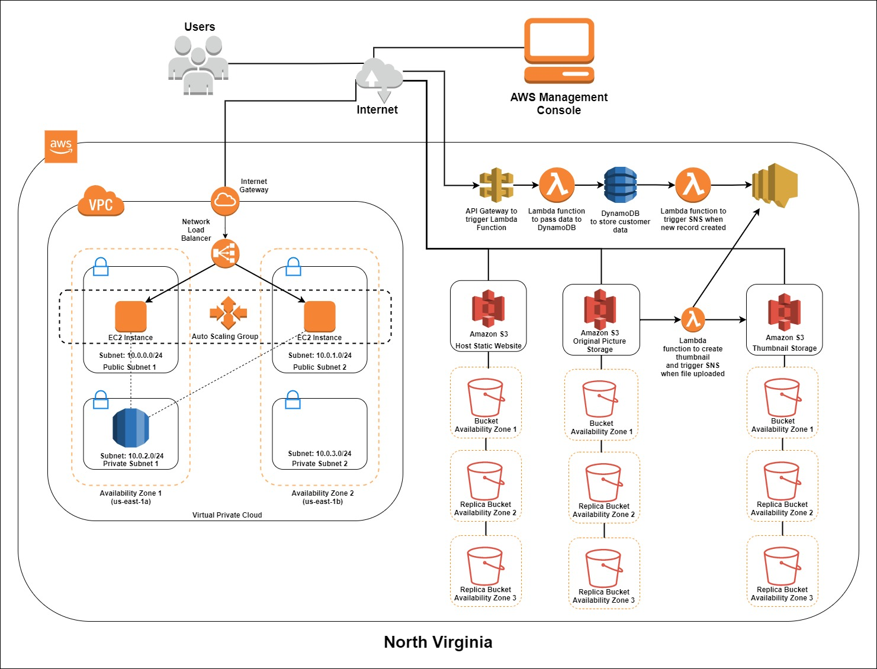

The EC2 will be configured as a Windows IIS Server, and it will be deployed in a VPC. The VPC consist of 4 subnets, 2 of which are public subnets and the other 2 are private subnets. To provide resilience, 2 different Availability Zones (AZ) are implemented. In each AZ, there are 2 subnets, one public and one private. The EC2 instances will be placed in the public subnets for both AZ and the Amazon Relational Database Service(RDS) will be placed in the private subnet for AZ 1 (us-east-1a). The instances are under the Auto Scaling Group (ASG). If the Amazon RDS is in the same VPC as the instances, the instances would be able to access the Amazon RDS although they are in different subnets. There is a load balancer attached to the instances. The purpose of the load balancer is to distribute traffic to the instances equally to not overwork any of the instances. There is an internet gateway attached to the VPC. The internet gateway is facing the internet. Additionally, we have used multiple s3 buckets, one to host a static webpage that contains our contact form, one to store original pictures uploaded and one to store the thumbnails. All S3 buckets are accessible to the internet. Any info passed to the static webpage will be handled to the API. It will then trigger the lambda to send the data to DynamoDB. This will in turn then trigger another lambda to trigger the SNS to send a notification.

## Web Server

### Assignment 2 VPC Configuration

Based on the business requirements, the web servers need to be built on IaaS Services. It needs to be resilient, load-balanced and elastic, meaning it must be able to scale out and in to match the demands of the network to the servers. The web servers should also store data in the Amazon RDS. To connect all the web servers and Amazon RDS together, we would need to create a VPC. Inside the VPC, it will have different subnets that contains the web servers and Amazon RDS respectively. All subnets will have a different range of IP address. Subnets that contain the web servers should be configured for public access and should have the ability to auto assign public IP address, whereas for subnets that contains the Amazon RDS should be configured only for private access.

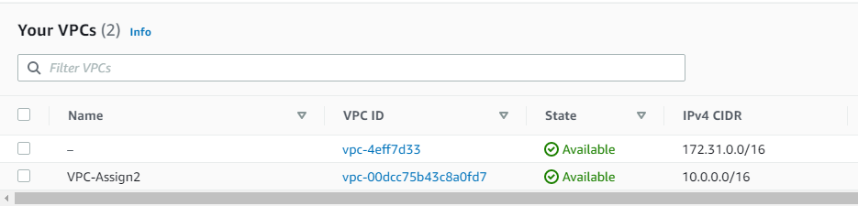

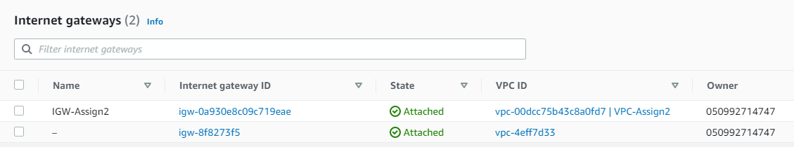

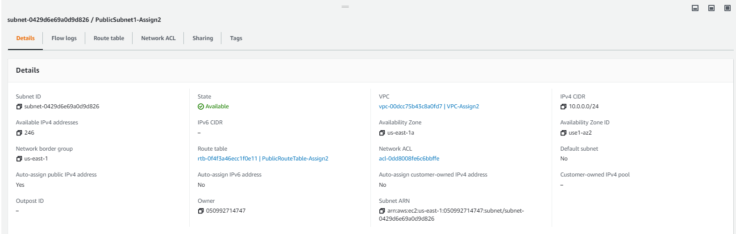

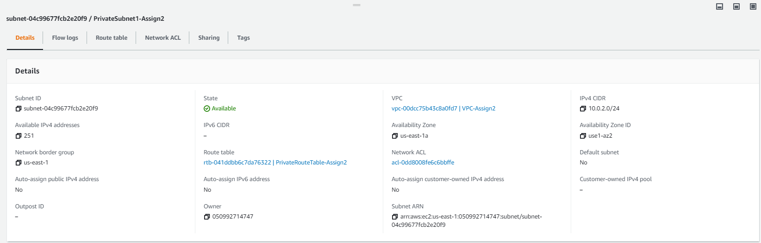

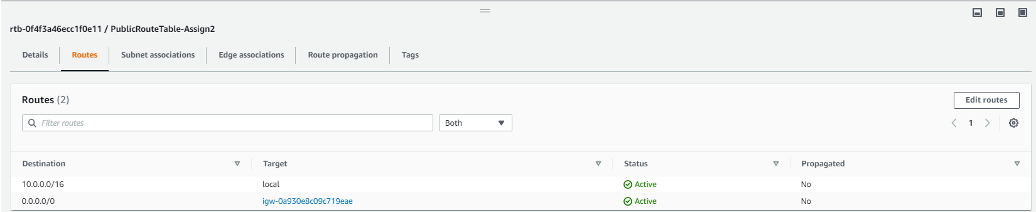

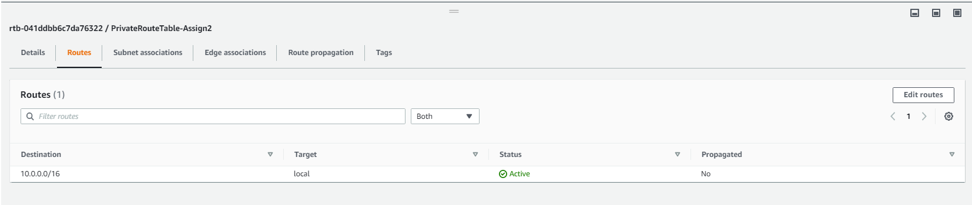

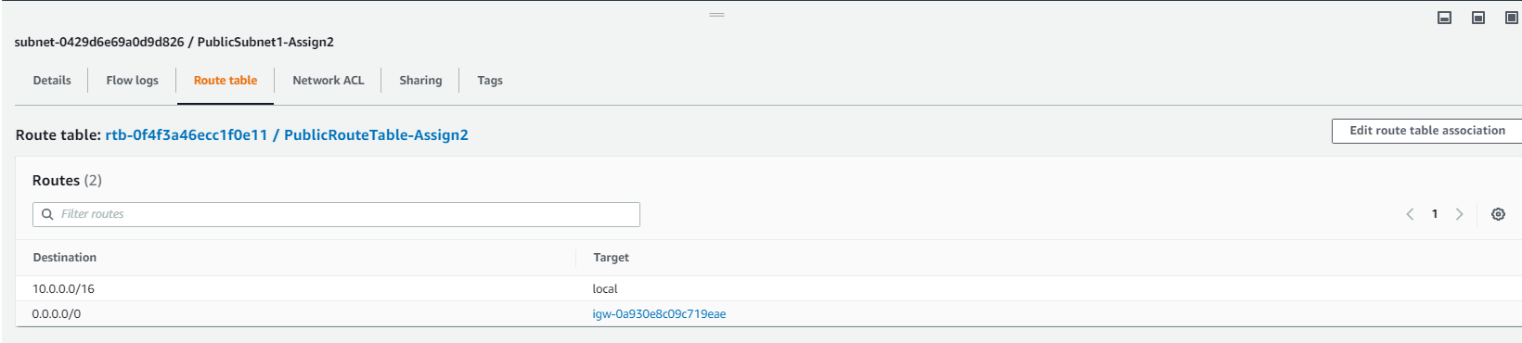

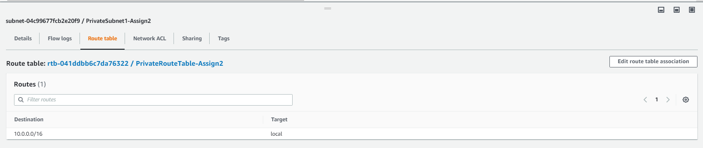

### EC2

Since the EC2 instance had to be configured as web servers, after doing some research, we figured the best choice was to use Microsoft windows server as it is more efficient to host the web server and connect the web servers to the Amazon RDS. Remote desktop (RDP) is needed to configure the web servers. It will be deployed using Internet Information Server (IIS) and ASP.NET 3.1 framework which will be connected to Amazon RDS. This web server will be fully configured before creating as a launch template for the auto scaling group. More details will be covered in the later sections.

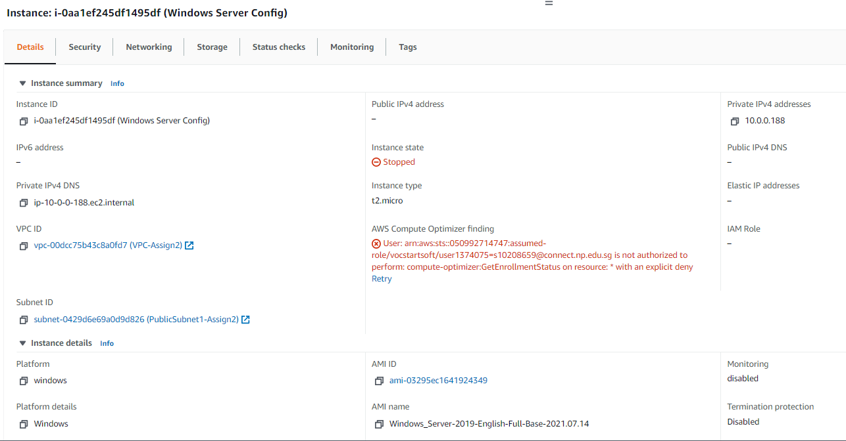

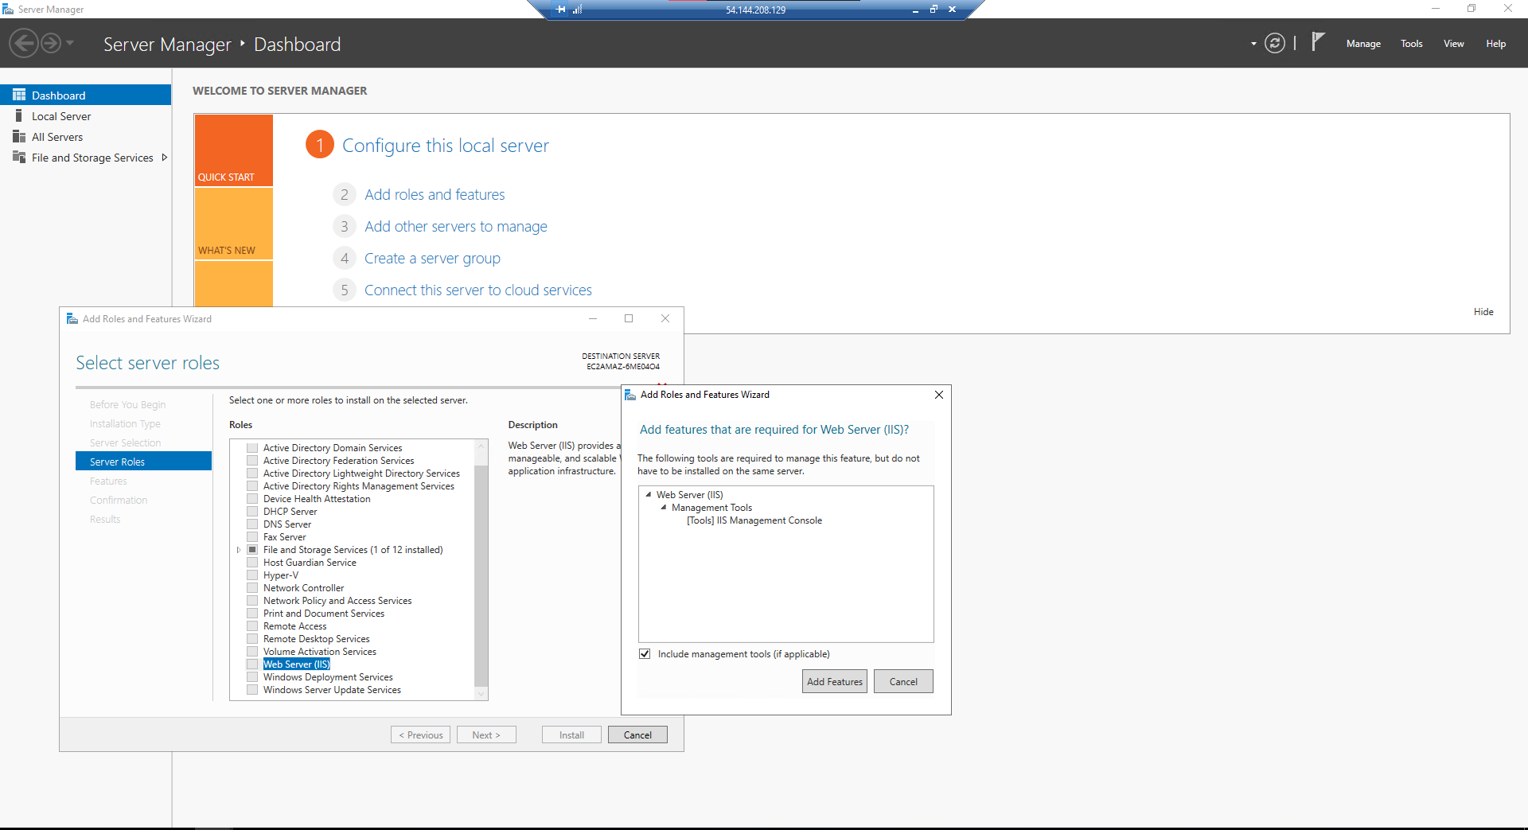

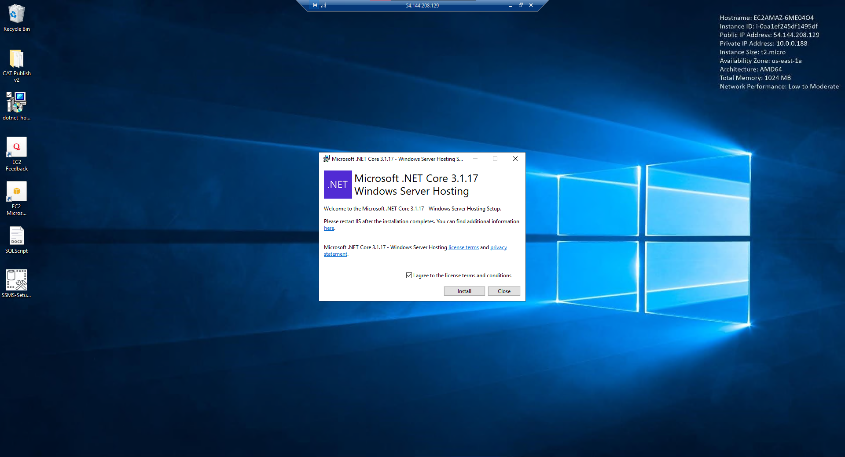

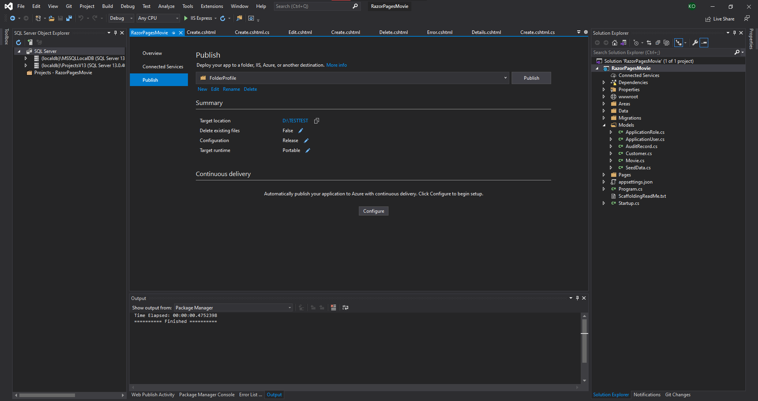

Specifying our Amazon RDS endpoint to allow our web server to interact with it

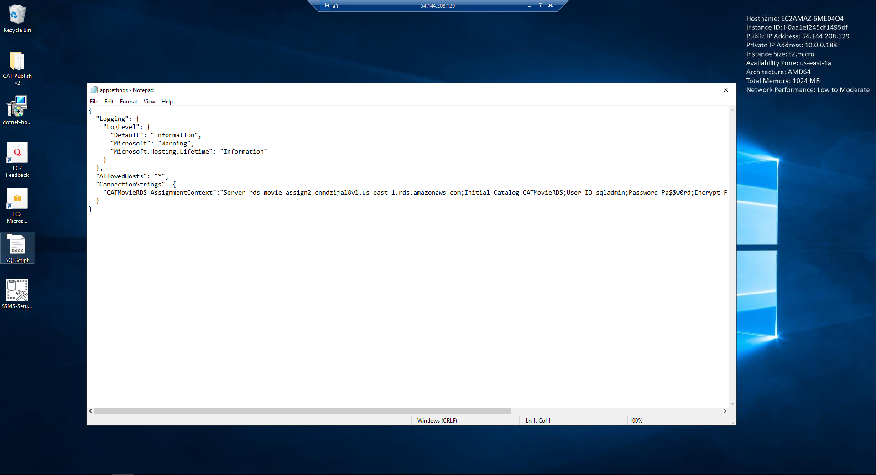

Checking out the movies tab and ensuring that the database has been linked correctly and entries in the database can be seen in the razor pages.

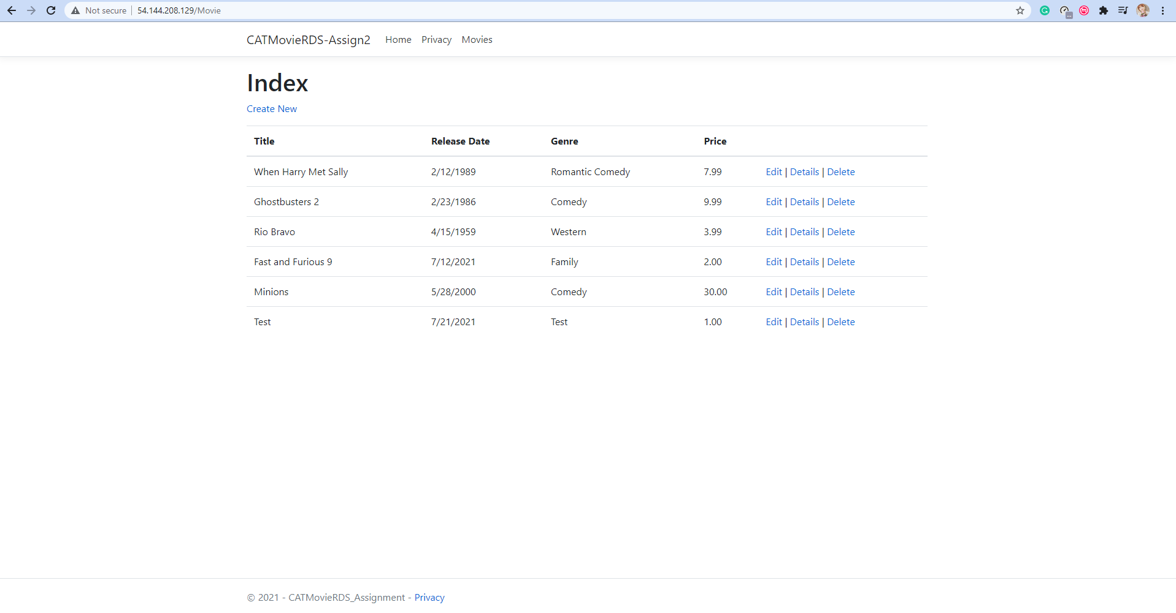

### RDS

As part of the business requirement, web server data should be stored in the Amazon RDS. Amazon RDS makes it easy to set up, operate, and scale a relational database in the cloud. It provides cost-efficient and resizable capacity while automating time-consuming administration tasks such as hardware provisioning, database setup, patching and backups. Hence, we will create an Amazon RDS to be used together with our web servers. After doing some research, we have found that a subnet group needs to be created with the private subnets added in. Since the private subnet is selected as the subnet group, the Amazon RDS will only be deployed in the private subnet. The reason why Amazon RDS is stored in the private subnet is so that only the web servers in the VPC can access. Moreover, providing security by restricting public access. Also, a security group must be created to allow the web servers to communicate with the database. After this, we need to initialize the database.

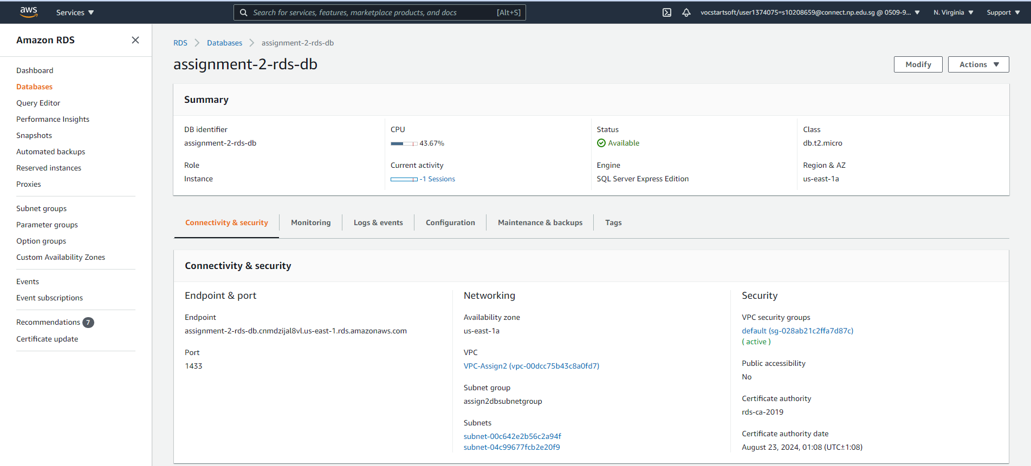

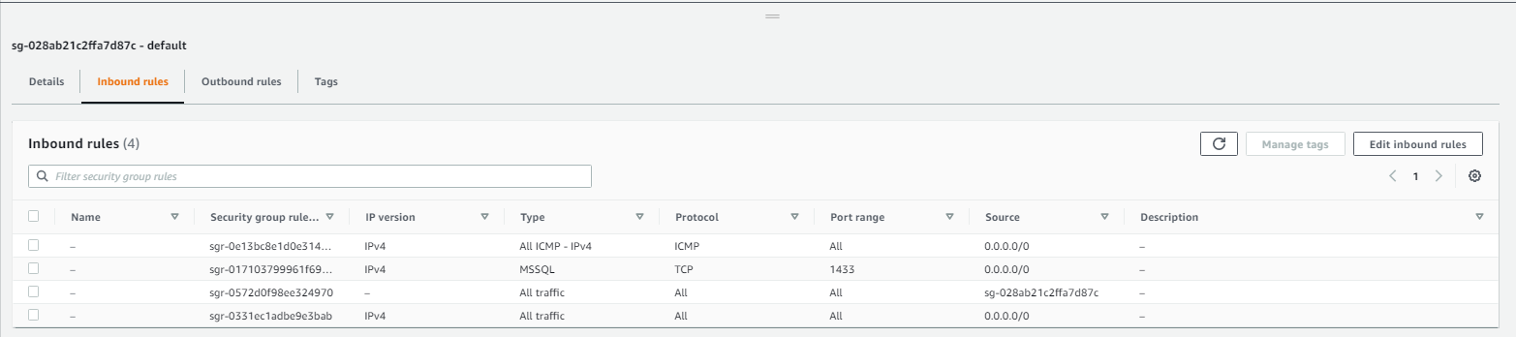

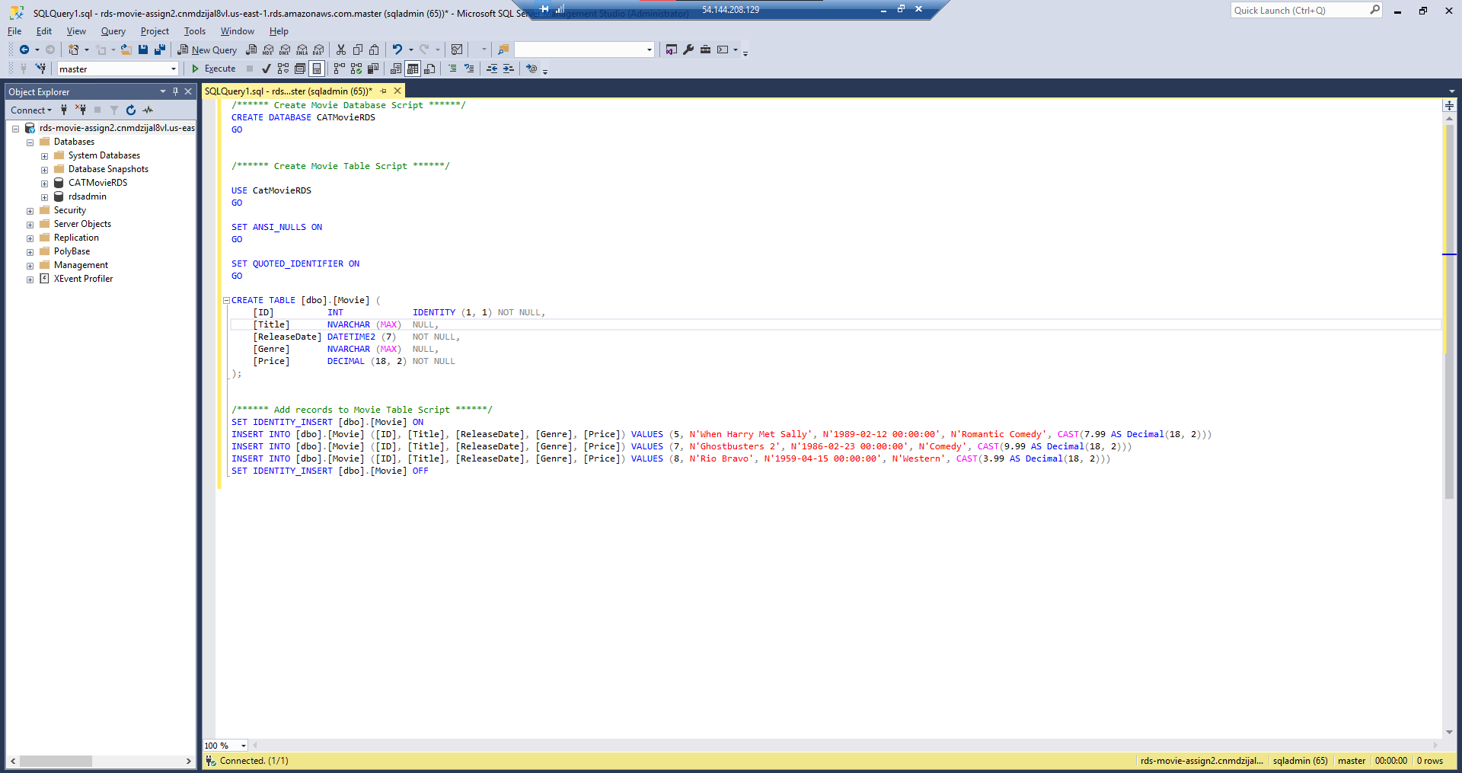

### Launch Template & Auto Scaling

As mentioned above, we will be using the fully configured web server to create our launch template. There is a feature in AWS to create an AMI. Therefore, we have decided to use this feature to be used for the Launch Template. This allows the auto scaling group to create predefined servers based on the AMI created.

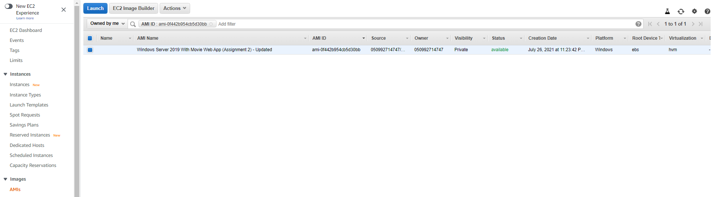

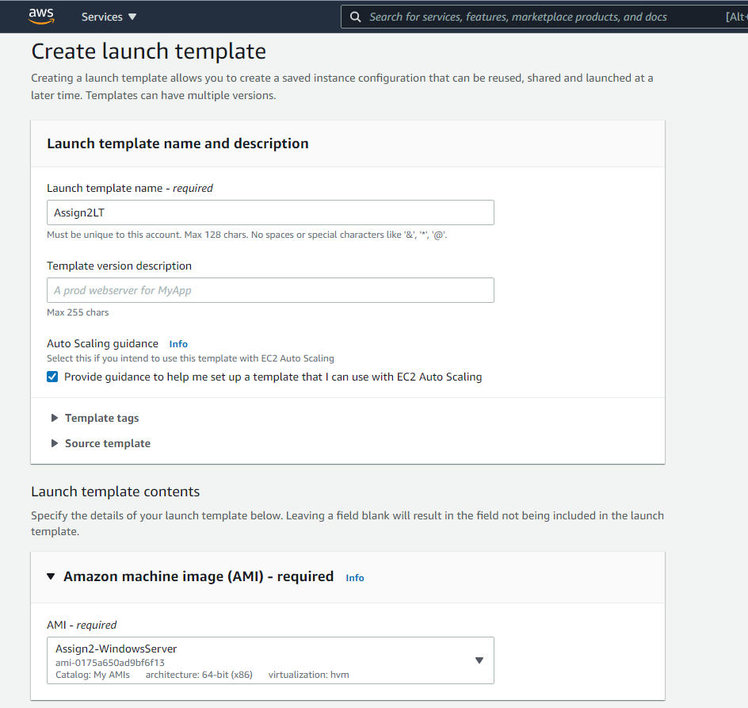

Successful creation of the launch template

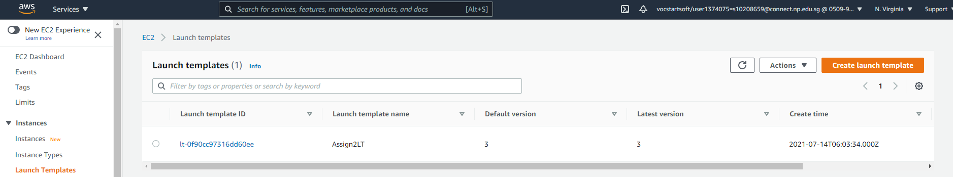

After creating the launch template, we would proceed to use this launch template to create our Auto Scaling Group. To achieve resiliency, two different Availability Zones (AZ) subnet (us-east-1a and us-east-1b) within the region is selected in the Auto Scaling Group (ASG) network configuration. Web servers that the auto scaling group launch will automatically assign the web servers into the target group of a load balancer. Referring to the business requirements, we were tasked to deploy at least two web servers running at one time. By doing so, in a scenario where one of the instances running in a subnet suddenly becomes unavailable, the ASG will deploy another instance automatically as the desired and minimum number of instances is set to 2. This will also result in no downtime as another instance is operational. During high network Demand, at least four web servers must be operating.

We concluded our desired metric threshold for the network in was 11000 bytes. This was discovered by creating an automated script to stimulate a high network traffic towards the web servers and monitored with CloudWatch.

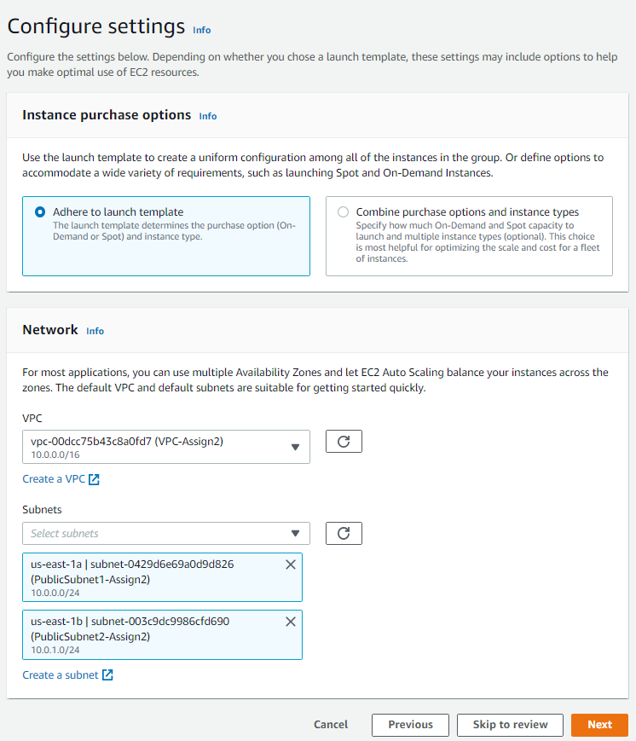

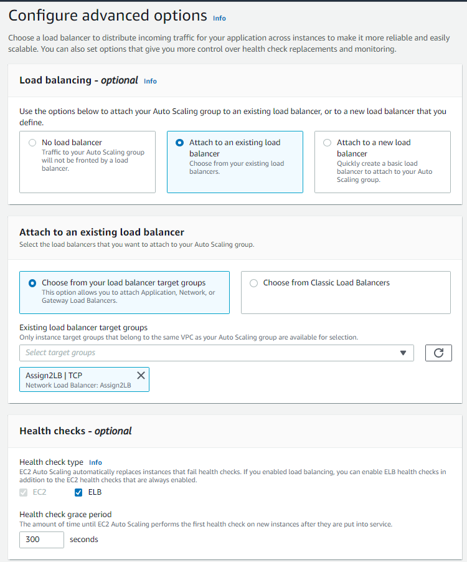

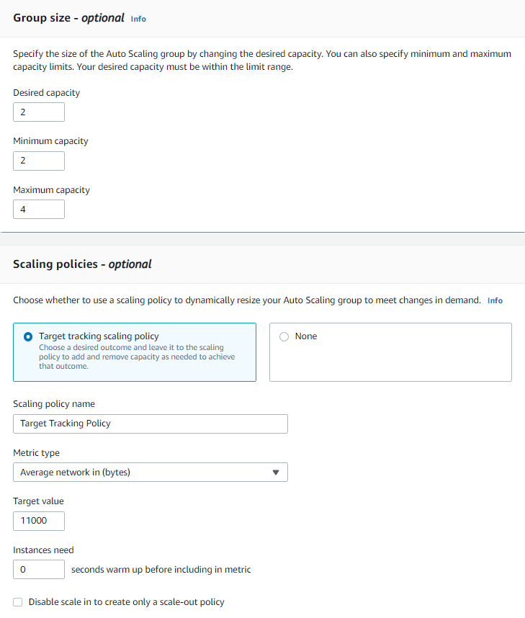

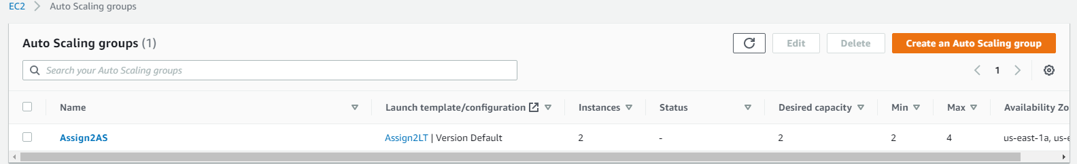

### Load Balancer

The purpose of a load balancer is to distribute network traffic across a number of servers.

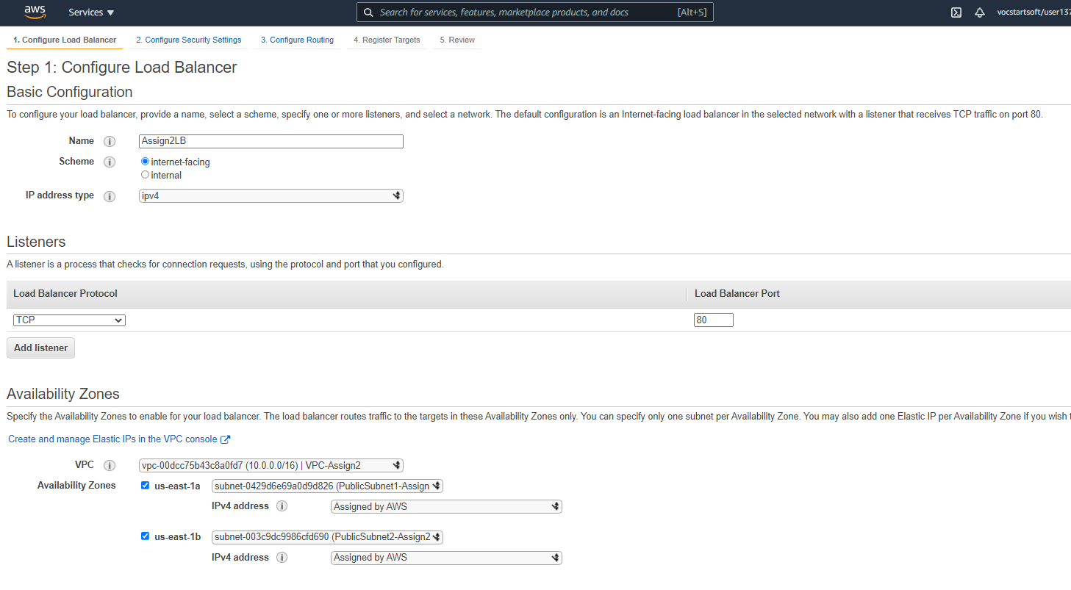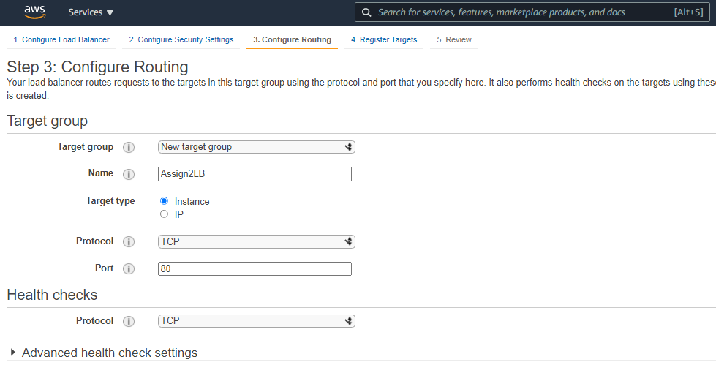

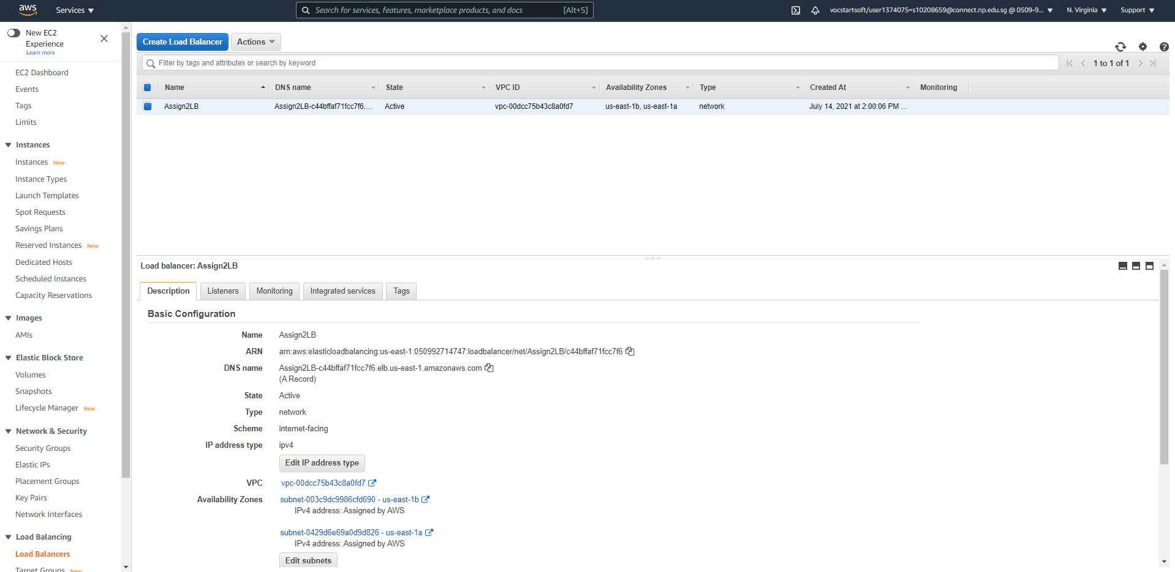

## Creation of SNS

Based on the business requirement, notification alerts via SMS to the administrator must be implemented. Amazon Simple Notification Service (SNS) is used to achieve this need as it enables sending of messages to users through various means such as SMS and email by adding subscriptions to the SNS Topic. Moreover, Amazon SNS can be integrated with event-driven serverless applications which enables us to create Lambda Functions to publish these notifications. More about how SNS Topic will be implemented will be discussed in the following sections of this report.

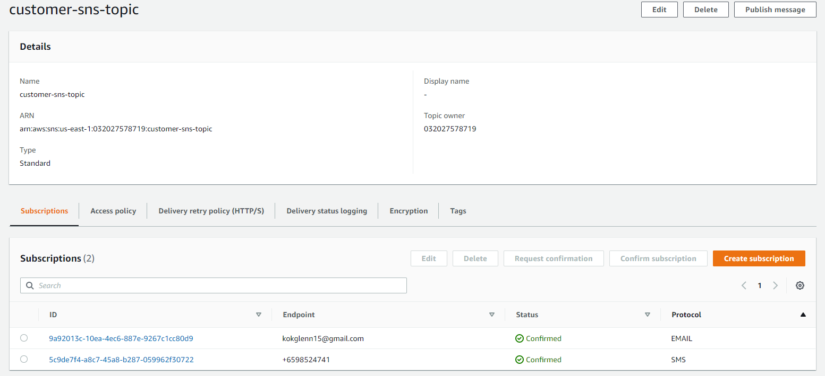

Creating the SNS Topic was simple to setup. For testing of implementation, Glenn’s email address and phone number was added to the subscription. However, when deployed, the subscriptions can be easily replaced with the administration’s contact details. The next step for us was to access solutions into publishing messages using triggers from other AWS services.

## DynamoDB

Looking back at the business needs, a NoSQL database is needed to store customer data. Hence, AWS DynamoDB is used as it is a key-value and document database that offers low latency queries at any scale. It is a fully managed, multi-region, multi-active, durable database with built-in security, backup and restore, and in-memory caching for internet-scale applications. Thus, using DynamoDB would provide high resiliency as well.

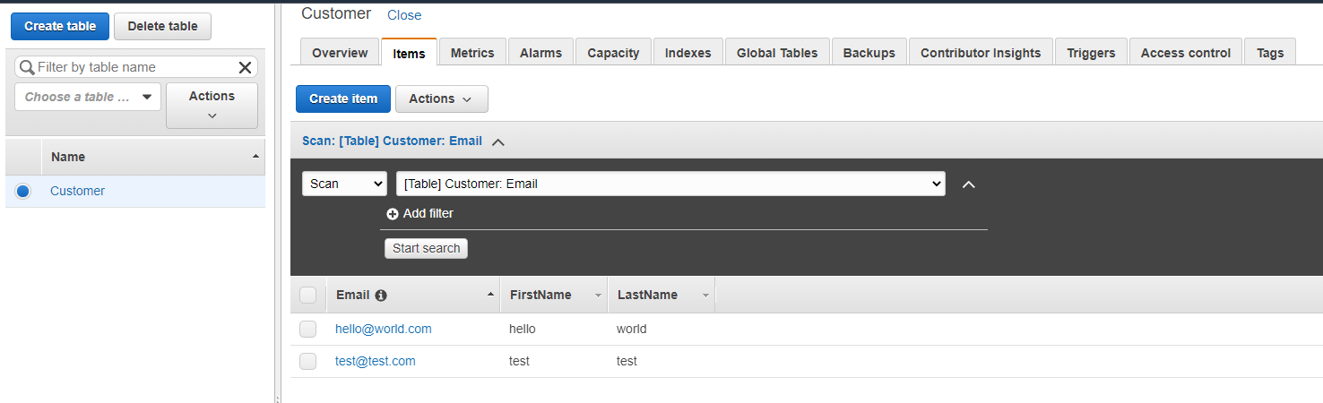

## DynamoDB Trigger Lambda to Publish SNS

After deploying the DynamoDB, architecting the interaction from the DynamoDB to serverless function is in progress. The lambda function would be used to publish the message to the SNS topic when an event from DynamoDB is triggered. After some research on exactly what triggers are and how it interacts with other AWS services, we learned about the procedures to integrate both services together. When an AWS Lambda is integrated with Amazon DynamoDB, it creates triggers which will automatically respond to events in DynamoDB Streams such as data modifications in DynamoDB tables. Initially, there was some issues creating a new trigger with the lambda function as the IAM policies attached to the IAM Role of the function had no permissions. Since we have little experience in configuring IAM policies and IAM roles, this poses a challenge for us.

Reading a documentation by AWS helped resolved our issue, we managed to configure an IAM policy for the Lambda function and integration to the DynamoDB trigger was successful. Despite reaching this checkpoint, another similar obstacle appeared. Since we had no knowledge of how AWS Lambda works, more research had to be done. Initially, understanding of how Lambda operates was difficult but after some reading of documentations, and trial and error, we managed to understand the syntax of the AWS SDK used in programming languages which enables the serverless function to interact with AWS resources. Therefore, the whole task was separated into smaller units as the implementation was quite overwhelming at first. The first stage was to understand how the Lambda function detects if an item from the Customer table is created. Second was to research on how the Lambda function would publish a message to the SNS topic. Lastly, combining both stages together and testing the results.

For the first approach, after looking online, we managed to understand that when an event trigger is configured to the Lambda function, checking what operation was performed can be done to determine if an item (Customer) was added. In this case, if the event trigger was ‘INSERT’, we can confirm that a new item was inserted into the Customer table and move to the second stage.

At this point, we were almost complete for this requirement, writing the code to publish a message to the SNS topic was not as difficult. Unfortunately, it was not as smooth sailing as we had imagined as we did not receive any emails or SMS after creating an item in the table. After moments of pondering about the issue, we came across a forum thread that mentioned about the IAM policy, we immediately checked the policies attached to the Lambda function role and realized that it did not have a policy to publish to the SNS Topic.

Following that discovery, we had created a new policy from a template and added the SNS Topic’s ARN to allow publish permission and attached the policy to the IAM role. With that, we successfully received an email and SMS notification from AWS after creating a new item in the table. However, our task was not complete. We added an extra step to notify when an item was changed with the ‘MODIFY’ event name, along with formatting the messages with information about the customer added.

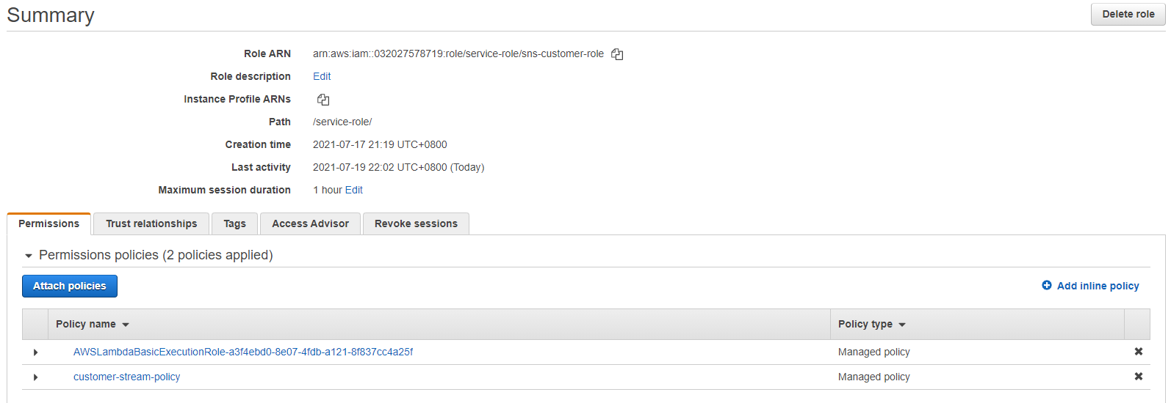  
Lambda function role

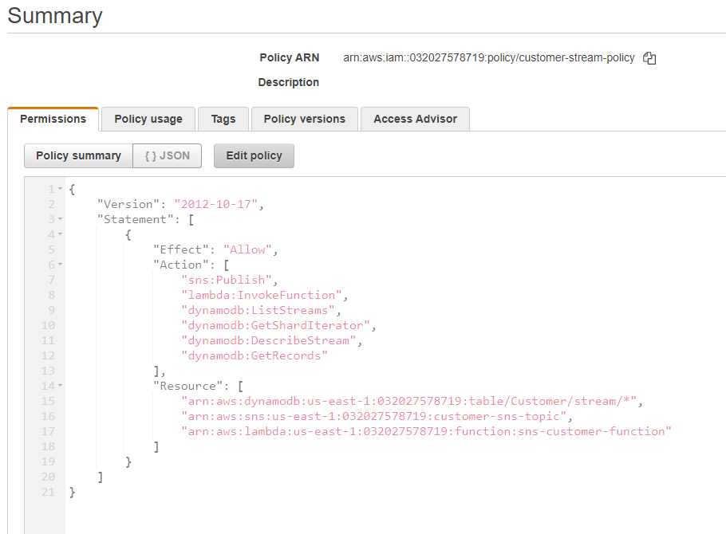  
Allow Lambda function to trigger DynamoDB and publish SNS

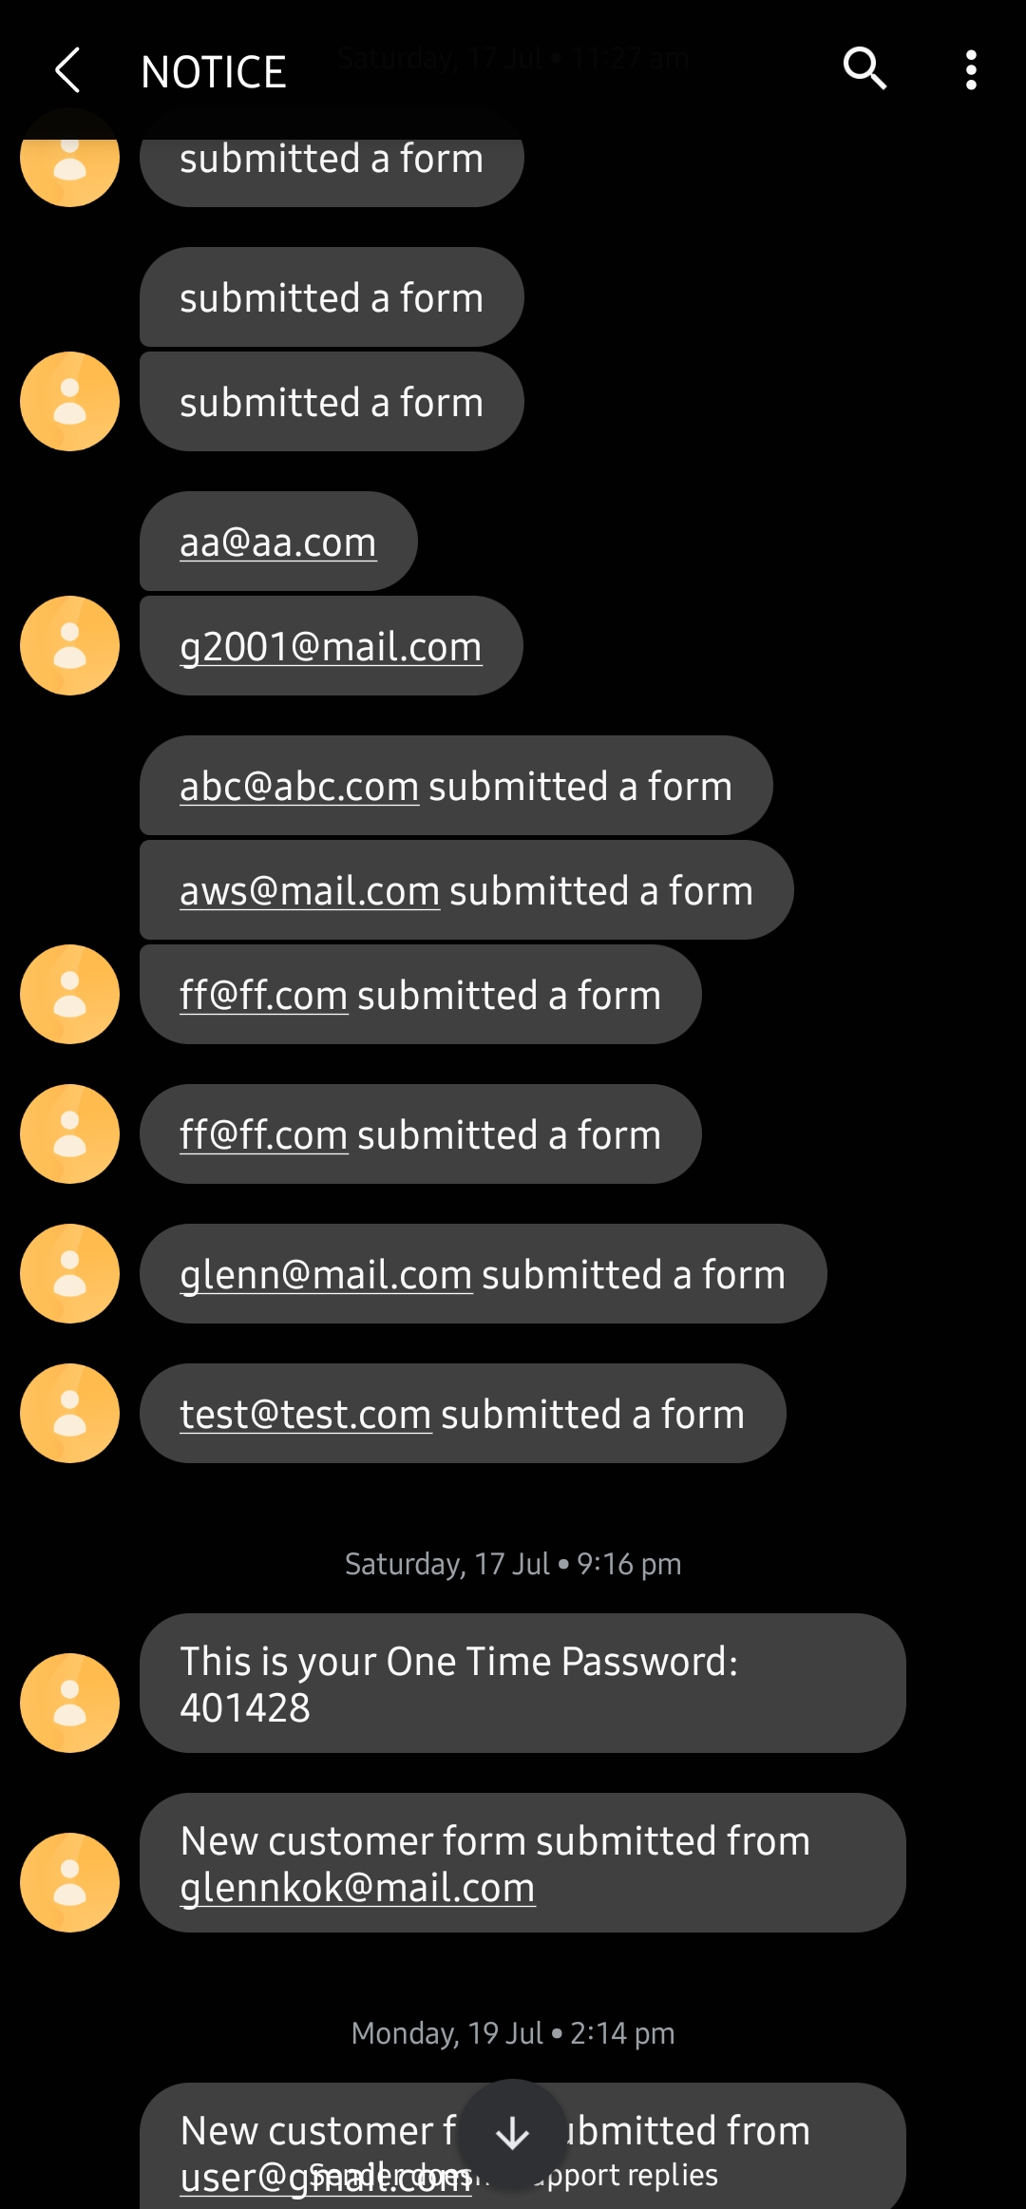

## S3 Trigger Lambda to Publish SNS

With the knowledge, we applied the same concept for implementation of the S3 bucket to notify the Administrator when a new file is added. Learning from our mistakes, after creating the Lambda function, we were sure to add the required policies to allow permission to publish to the SNS Topic and Read items in the bucket. We added a trigger on the Lambda function to the S3 bucket created. Since we want the function to execute when a file is added, ‘PUT’ was the event type to trigger. However, instead of only notifying that an item was added, we wanted to format the message saying who added it, which consist of the filename and the name of the bucket. For this, we needed to identify the absolute path to the data we want to retrieve. This is achieved by first sending the raw meta data and using a JSON visualizer helped us identify the structure of the raw format. Once we have identified the path, a couple of additional lines was added into the code to retrieve the data and the result was successful.

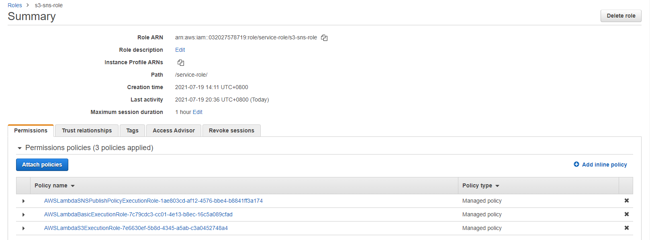

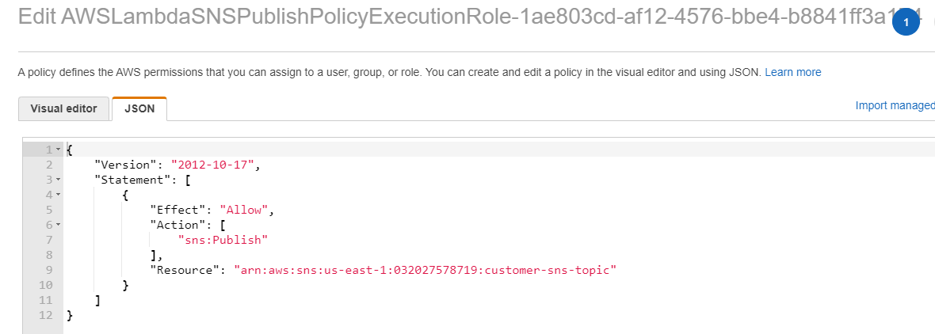

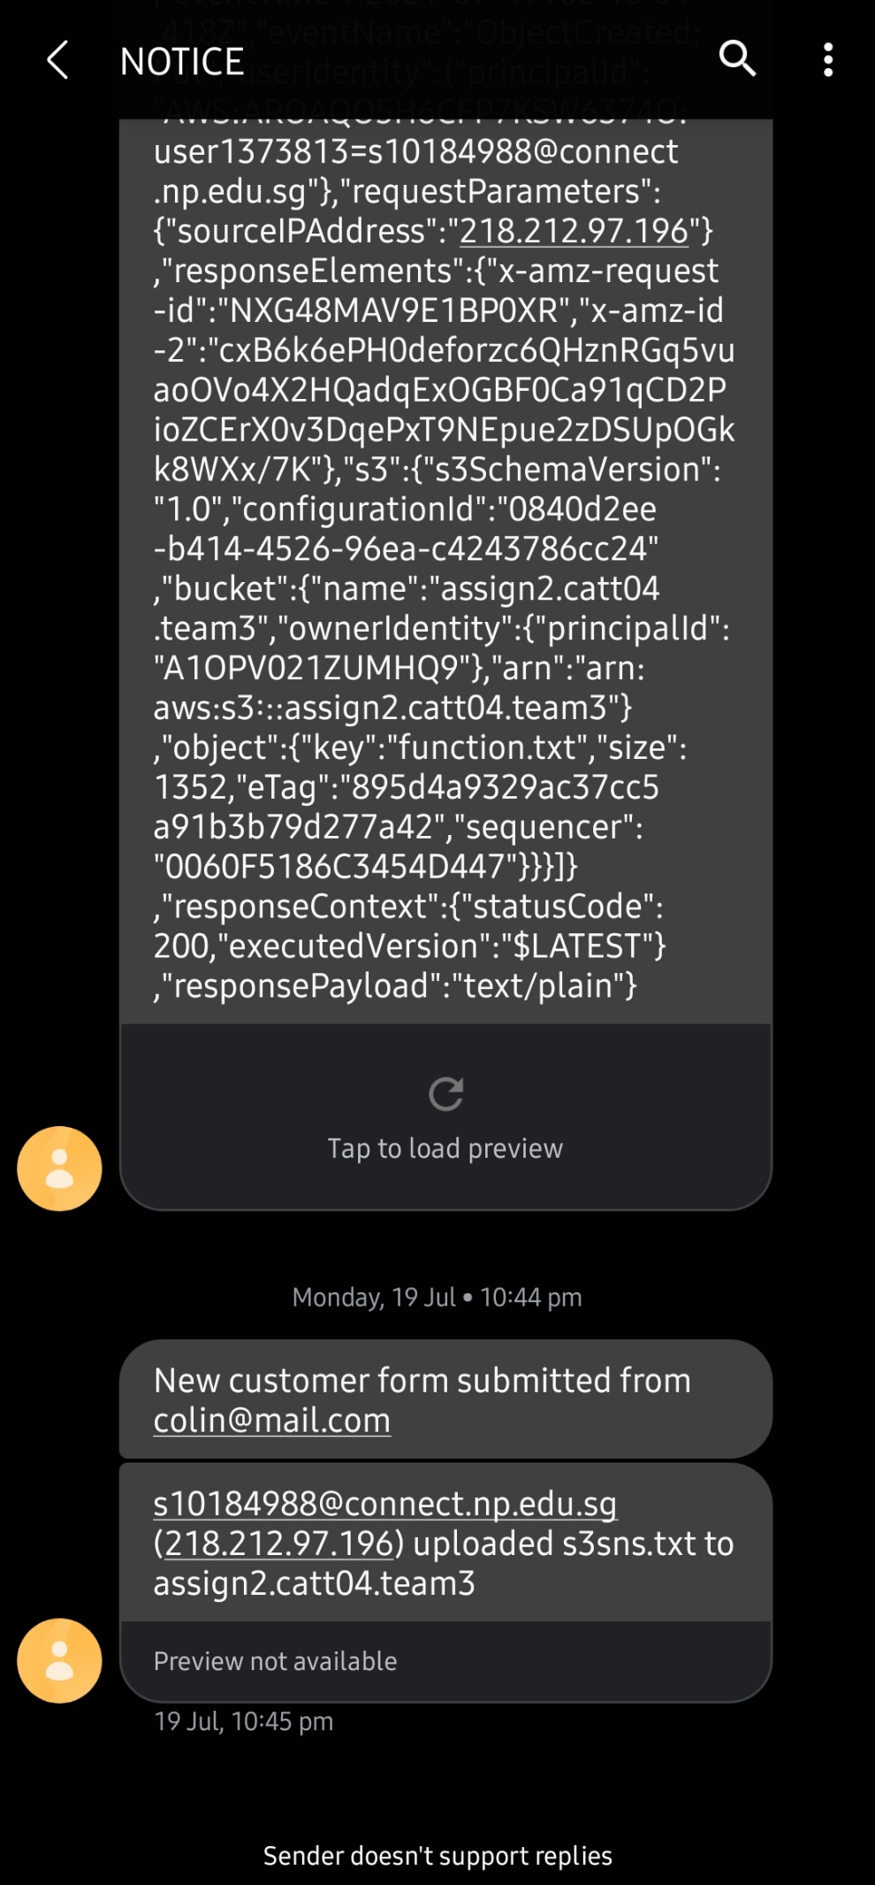

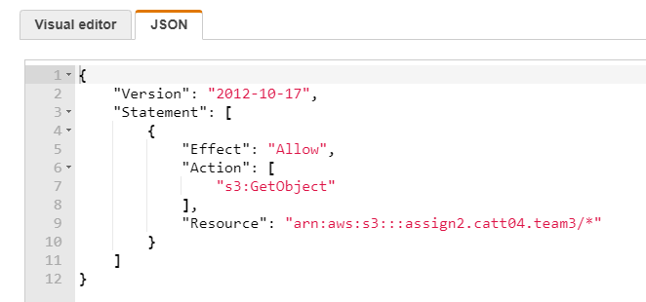

## API Gateway Trigger Lambda to DynamoDB

Expanding on the DynamoDB, the business requirements demand for the use to add Customers with the use of HTTP requests. Upon researching on what services are needed, we concluded that an API Gateway is needed in this architecture. However, when deciding between which API to use, we have settled for HTTP API instead of REST API. The reason for our choice is because HTTP APIs are designed for low latency, cost effective integrations with AWS services such as AWS Lambda which was what we need to send data to the DynamoDB. The diagram below depicts how the clients can utilize the HTTP API to interact with the serverless function and send data to the DynamoDB.

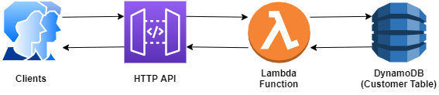

First, a lambda function is created to handle different route requests and process the correct procedures requested such as getting a customer info and adding a new customer. Next, for clients to make requests, the API Gateway was used to provide these routes for accessibility. Followed by integrating the Lambda Function created by attaching it to the routes in the API Gateway. This allows clients to send HTTP requests and interact with the Lambda Function through the API Gateway. Following that, the IAM Role for the Lambda Function must also contain a policy that allows it to interact with the Customer Table in DynamoDB.

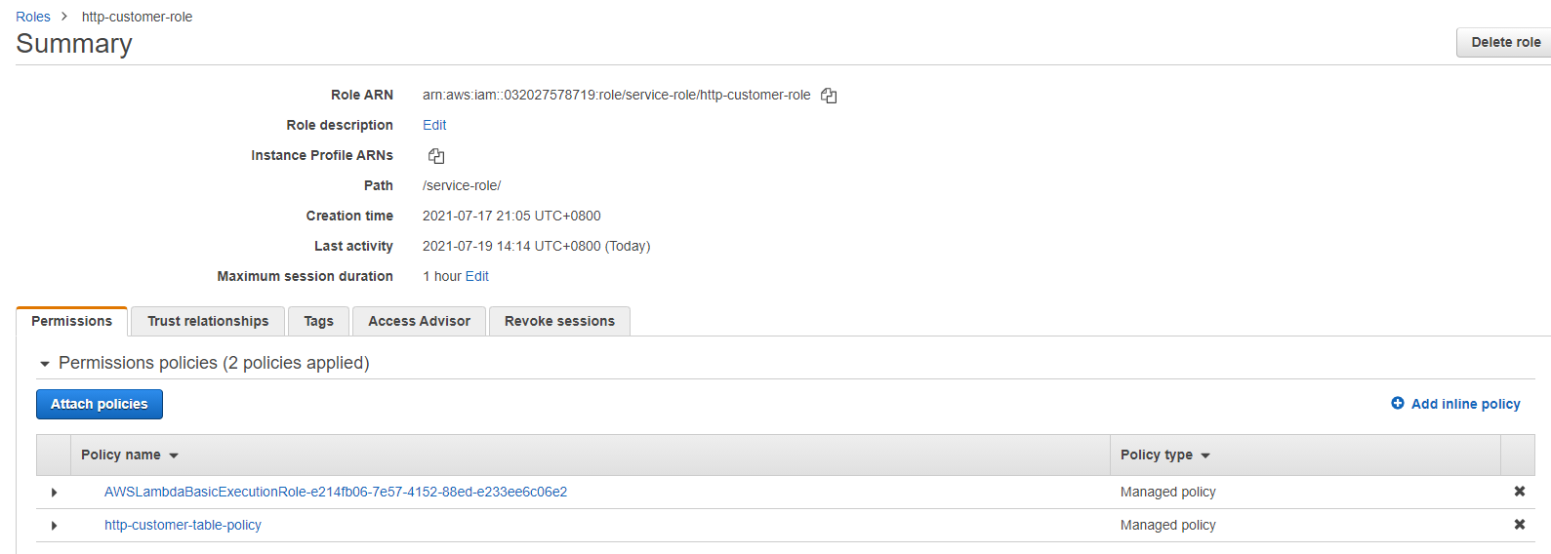

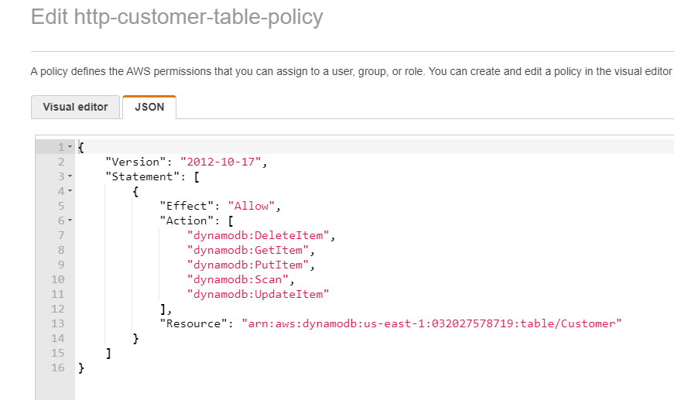

Based on our understanding of how the services are architected and some research on setting up an HTTP API, we first configured the routes for the API Gateway which are “GET” and “PUT”. The GET method allows us to read data while the “PUT” method allows us to insert or modify data in the Customer Table. For example, since “Email” was used as the partition key, if there is already a record with the same email, the existing record will be overwritten with the new data. In addition to creating the routes, a resource path must also be added. For example, when retrieving a specific item in the Customer Table, the path would be https://{aws-api-gateway}/items/{email}. Once the routes are defined, the Lambda function can be integrated with the route which allows the API Gateway to send data to the function.

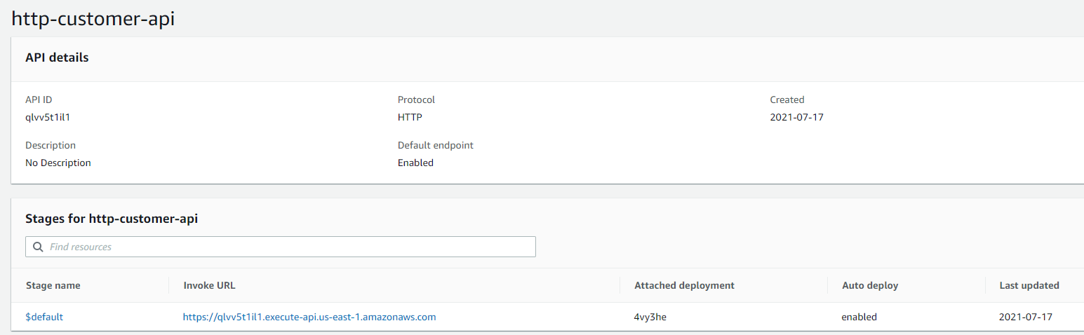

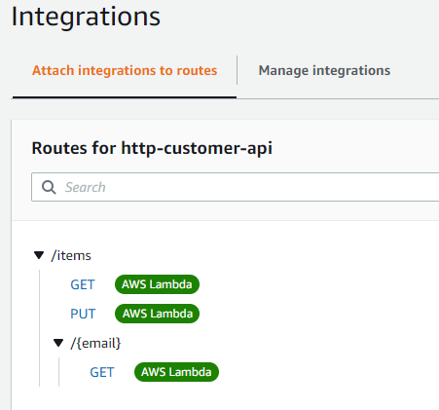

Writing the code to create a new item to DynamoDB was next. Although it was a challenge at first, we managed to come across a well-documented website that demonstrates how AWS Lambda interacts with a table in DynamoDB when triggered by a HTTP request. With reference from the documentation, we modified the program to suit our requirements. For testing of the API, we used an API client, Postman, to send the http requests to validate the result. First, we tried to retrieve data using GET request to the API and it was successful as shown in Figure 123. Instead of using Postman to send data, we wanted to see if implementation into an application was possible as we do not expect the clients to upload data using an API client or command line such as curl. We then tested with a Python program to send customer data using the PUT method to the API and the result was successful as shown in figure 123.

## HTML Form POST data to API Gateway

Following the completion of the API Gateway, we have decided to create an online form that takes in the name and email address of the customer. When the form is submitted, it will automatically create a record in the customer table. To accomplish this, we have attempted to apply the same logic as the Python code in Figure 123 into this implementation. For creation of the form, the front-end development was referenced from a free-to-use website. After some research on sending requests using JavaScript, we learned that AJAX can be used to perform this crucial task. AJAX stands for Asynchronous JavaScript And XML, and it allows the web page to send data to a server. In our case, it enables the static website to send a request to the API Gateway which then triggers the Lambda Function to create an item.

We studied and analyzed some code online about using AJAX and tried to write it independently to suit our need. During the trial-and-error phase, we were confident that the code could execute successfully but it resulted in a failure. Comparing with the Python code earlier, the logic was similar which resulted in more confusion for the team as we were uncertain about the cause of the failure. However, upon further investigations using the web browser developer tools, we noticed that the request was blocked by CORS policy. Initially, we were unsure of why this issue occurred but after a few hours of researching, we managed to resolve the issue. More details about the problem are explain in [LINK]. Finally, the integration of the whole architecture was successful as the form was able to send data to the DynamoDB using the lambda to forward the information, through the API Gateway. Expanding on this, since a new record was added, it would also trigger the Lambda Function to publish a message to SNS Topic and notify the administrator.

For hosting of the website, we have decided to use Amazon S3. Since the website to be hosted only contains a site with no backend database, using an S3 bucket was the easiest and fastest solution in deploying the form. Generally, public-read access is granted to the bucket to enable clients to access the website from the Internet as well as enabling static web hosting.

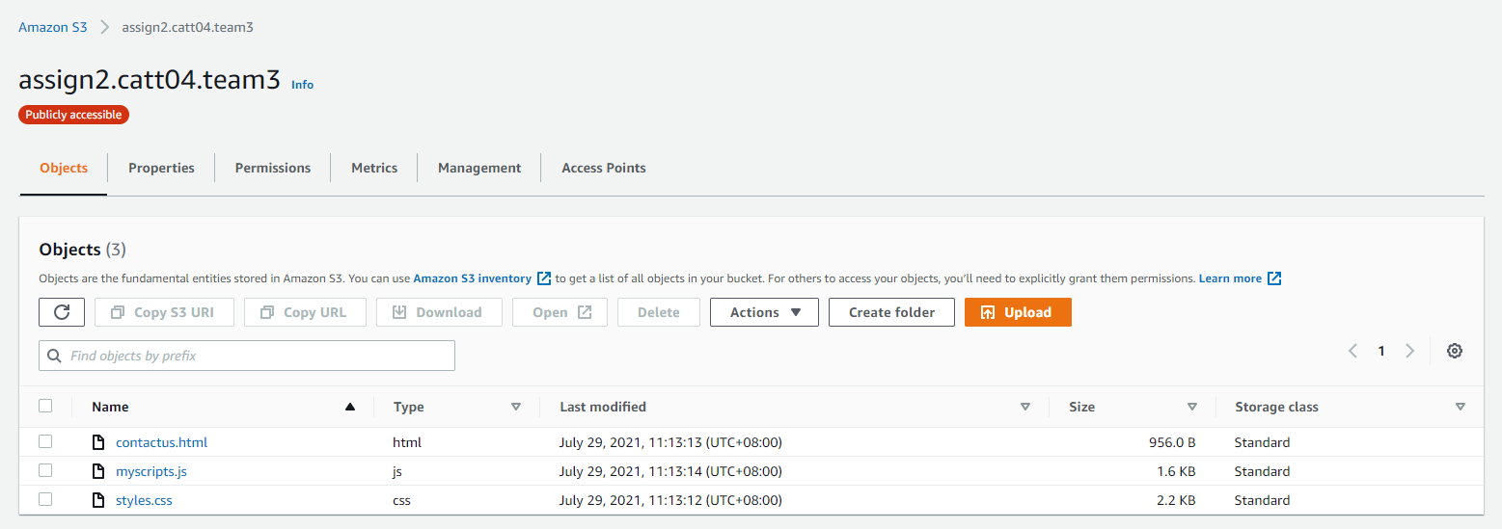

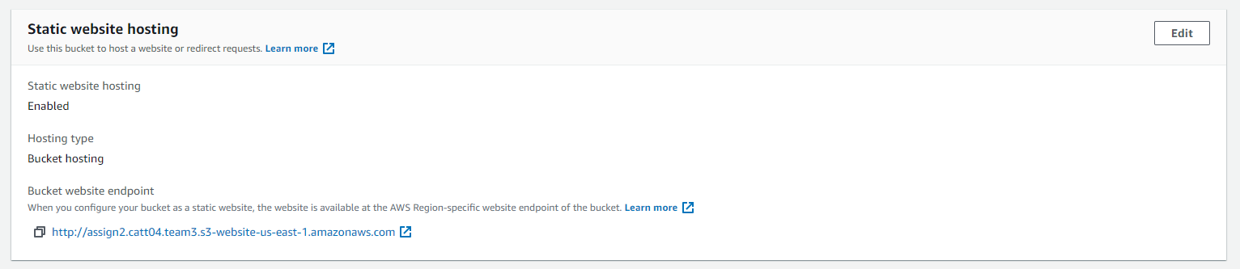

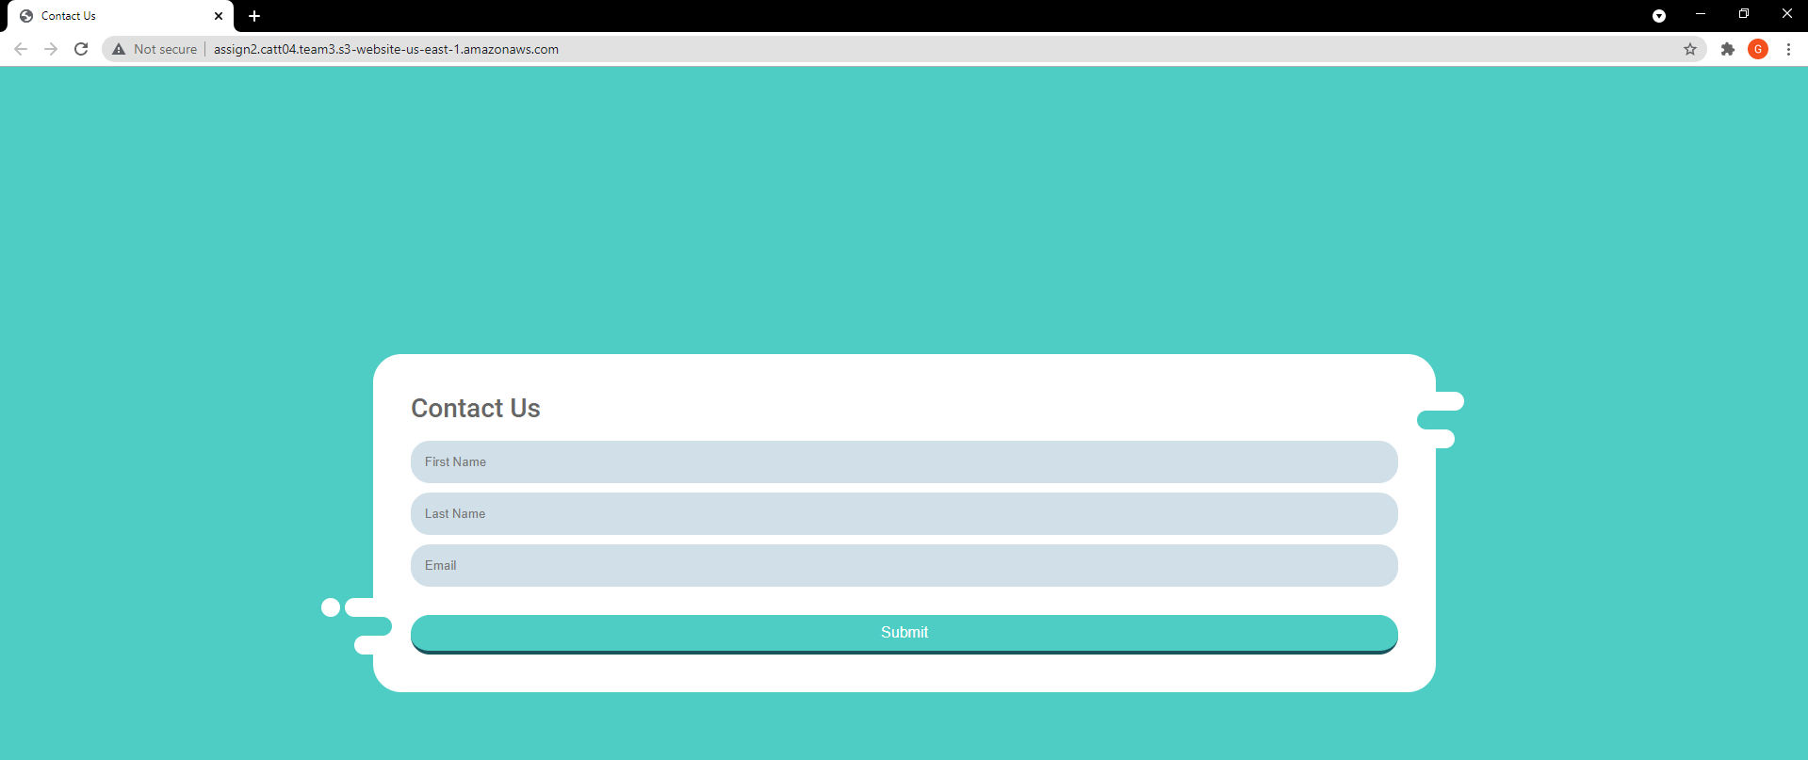  
The website can be accessed via this [link](http://assign2.catt04.team3.s3-website-us-east-1.amazonaws.com)

Next, we are creating a lambda function which will obtain and resize the image. However, we are required to prepare and create some resources first. Namely S3 Buckets, IAM Role and Policy, and the Lambda function. The two S3 Buckets are relatively simple to create, ‘thumbnail-asgn-source’ where the images will be placed in, and another bucket called ‘thumbnail-asgn-source-resized’ where the resized images will be placed after the lambda function executes.



After the creation of Lambda Function, a new policy must be created and attached to the functions IAM role. This policy would contain the permission to read from the source bucket and write to the destination bucket to allow access to the bucket resources. While referring to an AWS documentation and writing the Node.js script concurrently, we realized an external library called sharp was required to manipulate images. Therefore, the library must be installed locally and compressed together with the code as a deployment package.

Since the implementation of the thumbnail resize function, we felt that combining both this function and the S3 SNS function stated [here] would be more appropriate as it enables the administrator to know when an image is upload to the bucket as well. Integrating both function poses no issue as we just had to insert the publishing statement into the image resizing function.

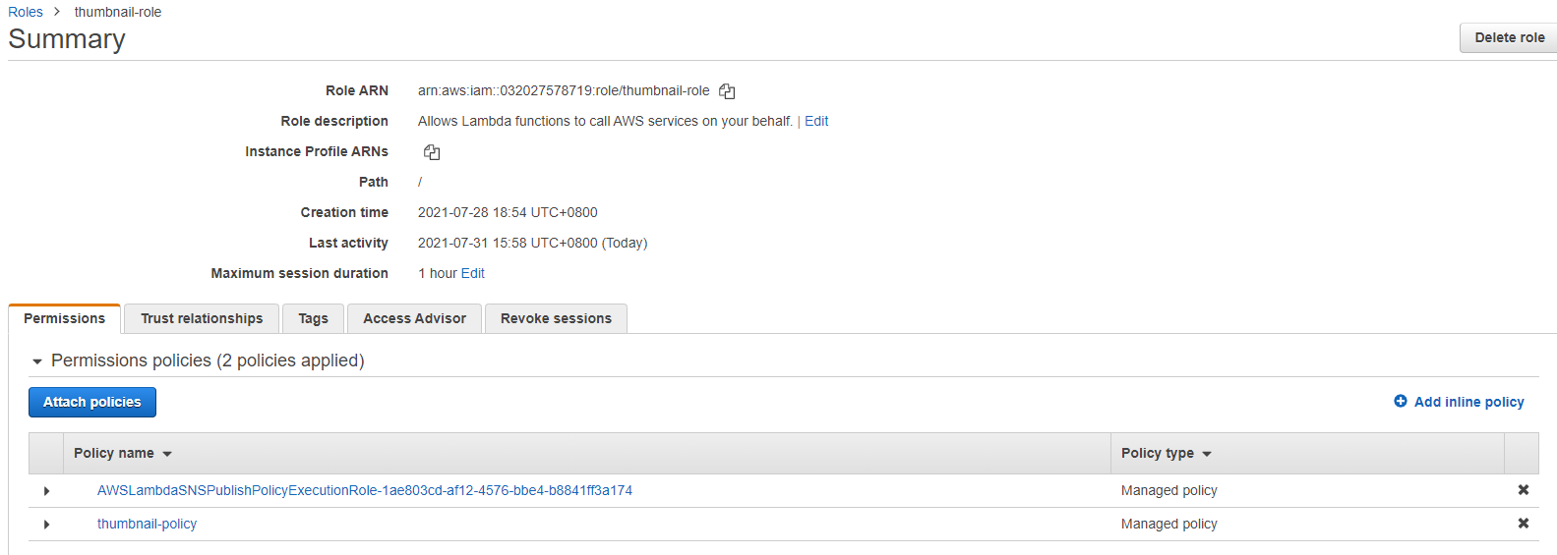

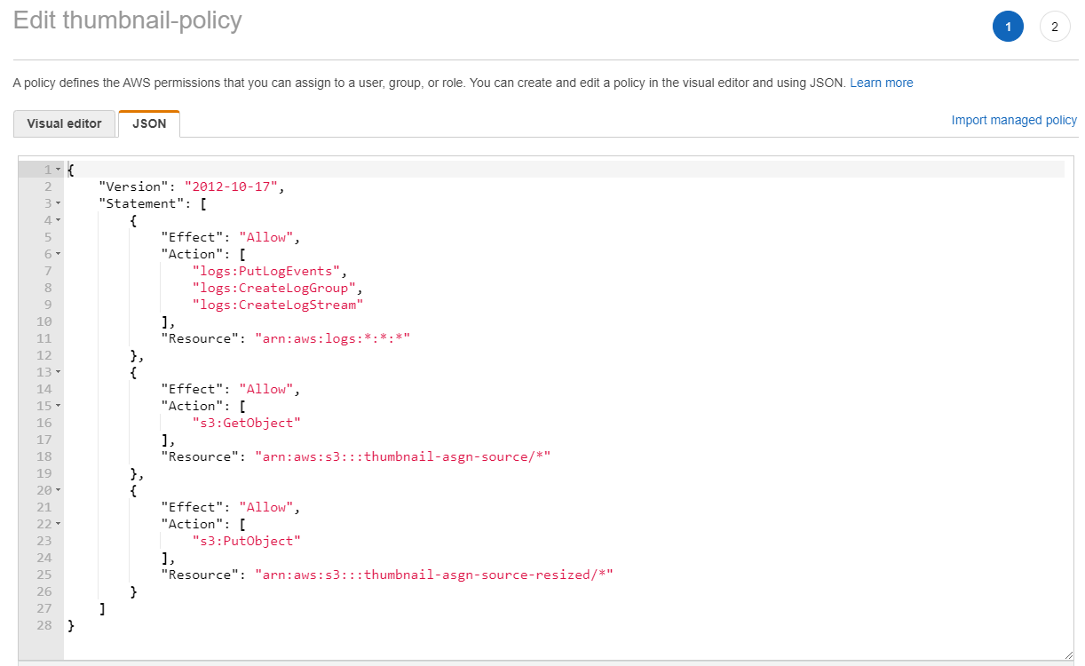

# Problems Encountered

## Problem 1 - Uploading Images to S3

We tried the lambda code with Python 3.8 first. However, there was an error with the python code. This error was caused by the “PIL” dependency and lambda was not able to retrieve the file. Different versions of python and the “PIL” dependency were tried but to no avail.

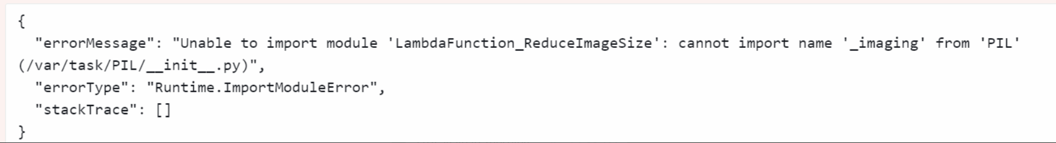

**Solution:**

Upon further research, we found out AWS Lambda’s runtime is paired with one of the Amazon Linux distributions, and thus could have compatibility issues with the python code made in windows. (<https://docs.aws.amazon.com/lambda/latest/dg/lambda-runtimes.html>) Thus, a Linux machine was used to create the deployment package. Node.js was used as it was the preferred programming language to use in a Linux environment.

## Problem 2 - Hosting a web application in the EC2

We have decided to host our own razor pages. However, it was a challenge as the web server was not showing the razor pages. It was at this moment when we realised that our files that were imported in were wrong and the dotnet hosting was on the wrong version.

**Solution:**

We went on to research on how to upload the razor pages. Initially, we thought that all we had to do was just to copy and paste the files into the IIS folder. Upon further research, we realised that we had to publish the razor pages before we could copy and paste it into the folder. After that, we had to find out version of dotnet hosting, which was 3.1.17. After installing the dotnet hosting, we then proceeded to upload the published razor pages files into the folder. Following that, we had to modify in the appsettings.json to use our Amazon RDS DB by specifying our Amazon RDS endpoint. We tested the web server after that, and everything was working fine.

## Problem 3 - Amazon RDS unable to be resilient.

During the period of implementing the resilient web servers, we came across an issue where we were unable to make our Amazon RDS resilient. We have researched and found something called Multi-Availability Zone (Multi-AZ). Multi-AZ automatically creates a primary DB instance and synchronously replicates the data to a secondary instance in a different AZ. Multi-AZ also provides Automatic Failover. Automatic Failover is when a storage volume on the primary instance fails in a multi-AZ deployment, Amazon RDS automatically initiates a failover and switches to the up-to-date standby secondary instance.

However, we are unable implement multi-AZ as it is not available in the free tier version of Microsoft SQL Server Express Edition. It is only available in other tiers like Microsoft SQL Server Standard/Enterprise Edition. We would run into issues like not enough credits if we wanted to deploy multi-AZ. This is the cheapest cost for Microsoft SQL Server Multi-AZ Deployment.

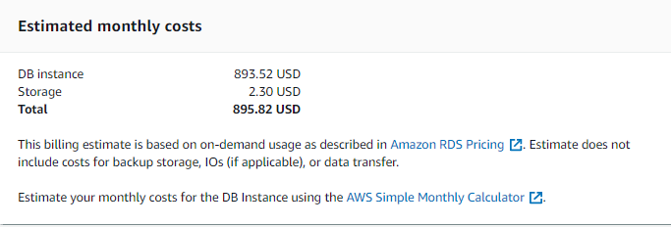

## SNS Topic SMS Limit

During the testing process of publishing messages to SNS Topic, the messages were successfully sent to the subscriptions configured (email and SMS). However, after 20 minutes of testing, we noticed that there was a delay in the SMS send. The message published would not send until another message was published. We continued testing but at one point, the SMS stopped coming in. Throughout this period, we were troubleshooting and even tried to revert the code back but to no avail. After looking online, a forum stated that there is a limit of 1 USD per month for SMS and can be increased by submitting a support request. But due to the limitations of the account permissions we have, increasing the limit was restricted and we had to migrate the architecture to another account and perform our SMS tests sparingly.

## Blocked by CORS Policy

Initially, we had no idea why the requests from the HTML form were blocked by CORS policy. After searching, it was stated that CORS is a mechanism that allows restricted resources on a web page to be requested from another domain. Based on the error message shown, we assumed that some parameters in the header were missing. From there, we modified the AJAX request to allow all for the Access-Control-Allow-Origin but to no avail. After probing around the settings in the API Gateway, we noticed that there was a CORS configuration settings. Some configurations in the settings were done as shown in Figure 123. With that, the request was successfully sent with no present issues.

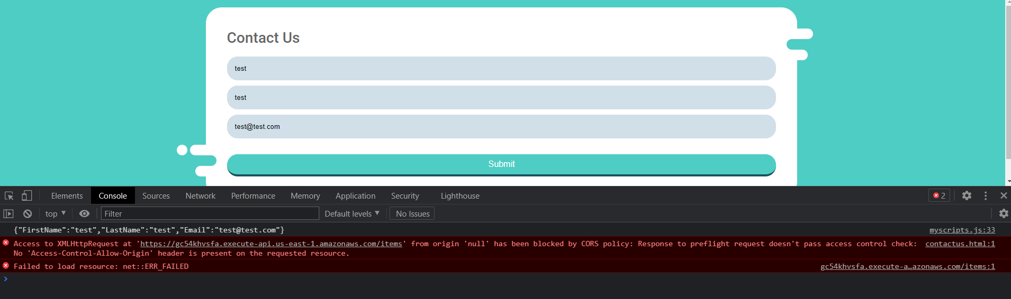

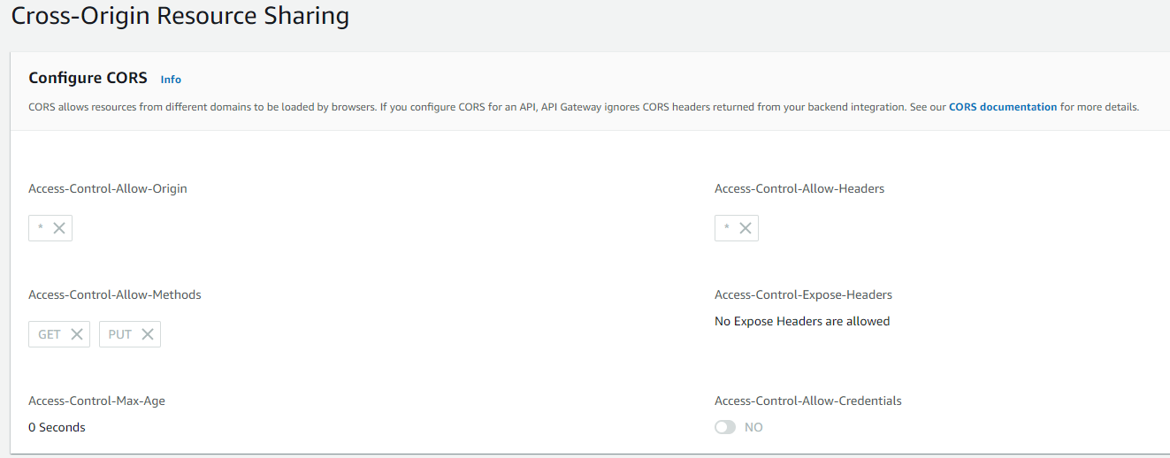

# Code used for the Lambda functions

## DynamoDB Publish SNS Function

|  |
| --- |
| **sns-customer-function** |
| var AWS = require("aws-sdk");  var sns = new AWS.SNS();  exports.handler = (event, context, callback) => {  event.Records.forEach((record) => {  console.log('Stream record: ', JSON.stringify(record, null, 2));  var name = record.dynamodb.Keys.Email.S;  if (record.eventName == 'INSERT') {  var params = {  Subject: 'New Customer',  Message: 'New customer form submitted from ' + name,  TopicArn: 'arn:aws:sns:us-east-1:032027578719:customer-sns-topic'  };  notify(params)  }  else if (record.eventName == 'MODIFY'){  var params = {  Subject: 'Customer Modified',  Message: 'Customer '+name+' has changed his/her name',  TopicArn: 'arn:aws:sns:us-east-1:032027578719:customer-sns-topic'  };  notify(params)  }  });    callback(null, `Successfully processed ${event.Records.length} records.`);    function notify(params){  sns.publish(params, function(err, data) {  if (err) {  console.error("Unable to send message. Error JSON:", JSON.stringify(err, null, 2));  } else {  console.log("Results from sending message: ", JSON.stringify(data, null, 2));  }  });  }  }; |
| In this lambda function, written in node.js, it basically uses the SNS library from the AWS SDK and calls the publish method with the required parameters which are ‘Subject’, ‘Message’, and the ARN of the SNS Topic. However, this is only executed when an item is added or changed, the message is different depending on the condition as well. |

## S3 Resize Image Function

|  |
| --- |
| **thumbnail-function** |
| const AWS = require('aws-sdk');  const util = require('util');  const sharp = require('sharp');  const s3 = new AWS.S3();  const sns = new AWS.SNS();  exports.handler = async (event, context, callback) => {  // Read options from the event parameter.  console.log("Reading options from event:\n", util.inspect(event, {depth: 5}));  const srcBucket = event.Records[0].s3.bucket.name;  // Object key may have spaces or unicode non-ASCII characters.  const srcKey = decodeURIComponent(event.Records[0].s3.object.key.replace(/\+/g, " "));  const dstBucket = srcBucket + "-resized";  const dstKey = "resized-" + srcKey;  // Get the object from the event and show its content type  const srcIP = event.Records[0].requestParameters.sourceIPAddress  const user = event.Records[0].userIdentity.principalId.split("=")[1];    //SNS Topic  var snsParams = {  Message: `${user} (${srcIP}) uploaded ${srcKey} to ${srcBucket}`,  TopicArn: 'arn:aws:sns:us-east-1:032027578719:customer-sns-topic'  }  sns.publish(snsParams, function(err, data) {  if (err) console.log(err, err.stack);  else console.log('Message sent successfully');  });  // Infer the image type from the file suffix.  const typeMatch = srcKey.match(/\.([^.]*)$/);  if (!typeMatch) {  console.log("Could not determine the image type.");  return;  }  // Check that the image type is supported  const imageType = typeMatch[1].toLowerCase();  if (imageType != "jpg" && imageType != "png") {  console.log(`Unsupported image type: ${imageType}`);  return;  }  // Download the image from the S3 source bucket.  try {  const params = {  Bucket: srcBucket,  Key: srcKey  };  var origimage = await s3.getObject(params).promise();  } catch (error) {  console.log(error);  return;  }  // set thumbnail width. Resize will set the height automatically to maintain aspect ratio.  const width = 200;  // Use the sharp module to resize the image and save in a buffer.  try {  var buffer = await sharp(origimage.Body).resize(width).toBuffer();    } catch (error) {  console.log(error);  return;  }  // Upload the thumbnail image to the destination bucket  try {  const destparams = {  Bucket: dstBucket,  Key: dstKey,  Body: buffer,  ContentType: "image"  };  const putResult = await s3.putObject(destparams).promise();    } catch (error) {  console.log(error);  return;  }    console.log('Successfully resized ' + srcBucket + '/' + srcKey +  ' and uploaded to ' + dstBucket + '/' + dstKey);  }; |
| When the function is triggered, it retrieves information of the item added and publishes a message to the SNS topic. The detail consist of name of the user, IP address, file name and bucket name. If the file is an image(.jpg, .png), the image size would be reduced. The resized image would be uploaded to another bucket. |

## API Gateway Lambda Function to DynamoDB

|  |
| --- |
| http-customer-function |
| const AWS = require("aws-sdk");  const dynamo = new AWS.DynamoDB.DocumentClient();  exports.handler = async (event, context) => {  let body;  let statusCode = 200;  const headers = {  "Content-Type": "application/json"  };  try {  switch (event.routeKey) {  case "GET /items/{email}":  body = await dynamo  .get({  TableName: "Customer",  Key: {  Email: event.pathParameters.email  }  })  .promise();  break;  case "GET /items":  body = await dynamo.scan({ TableName: "Customer" }).promise();  break;  case "PUT /items":  let requestJSON = JSON.parse(event.body);  await dynamo  .put({  TableName: "Customer",  Item: {  Email: requestJSON.Email,  FirstName: requestJSON.FirstName,  LastName: requestJSON.LastName  }  })  .promise();  body = `Put item ${requestJSON.email}`;  break;  default:  throw new Error(`Unsupported route: "${event.routeKey}"`);  }  } catch (err) {  statusCode = 400;  body = err.message;  } finally {  body = JSON.stringify(body);  }  return {  statusCode,  body,  headers  };  }; |
| In this script, when an API Gateway receives a GET or PUT request, the function would execute. For example, when a PUT request was sent and the resource path was ‘/items’, it indicates that a new customer should be added. The ‘dynamo.put()’ method in the DynamoDB library would be used to add a new item. The parameter consists of the table name and item information. The information is retrieved from the body of the request and parsed into a JSON format. If any errors occurred, the status code would be 400, and 200 if successful. |

# Tools to Create & Test Infrastructure

## Testing HTTP Requests to API Gateway

For testing of the HTTP API, Postman was used to send a GET request while a Python program was used to send a PUT request. If the GET request was successful, the items in the Customer table would be shown as depicted in Figure 123. Moreover, if the PUT request was successful, the status would be shown which in this case is 200, meaning success.

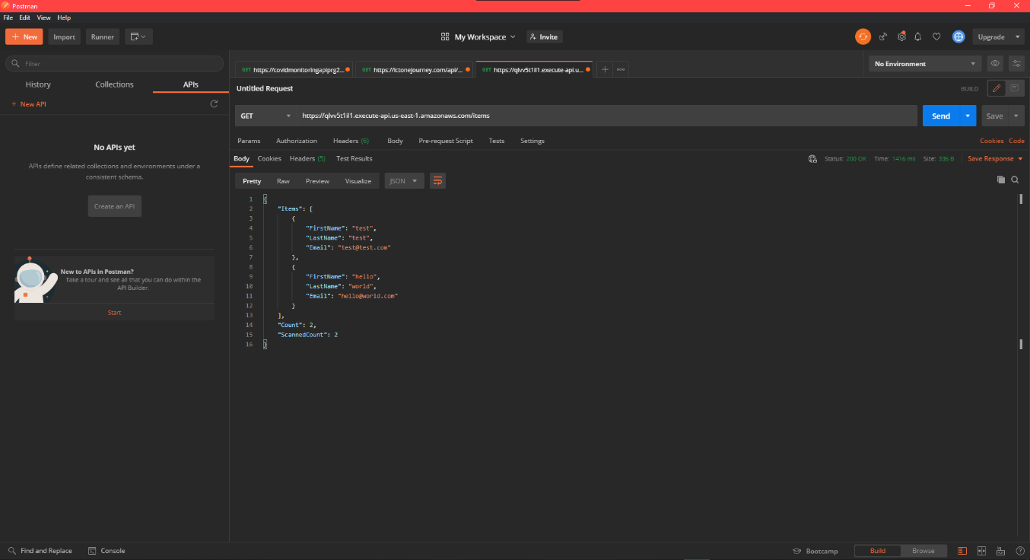

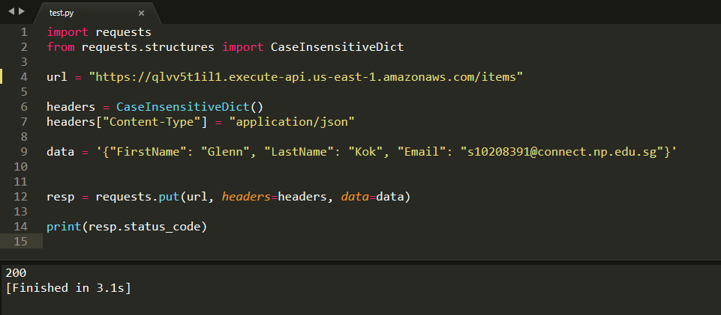

## Testing auto scaling

To test the auto scaling, we will be using a python script to stimulate real life usage. Once the script finish executing, auto scaling will scale out to the maximum capacity to cater to the high demand. All instances will have the razor pages installed on them. When there is low demand, the auto scaler will scale to the minimum capacity to save cost.

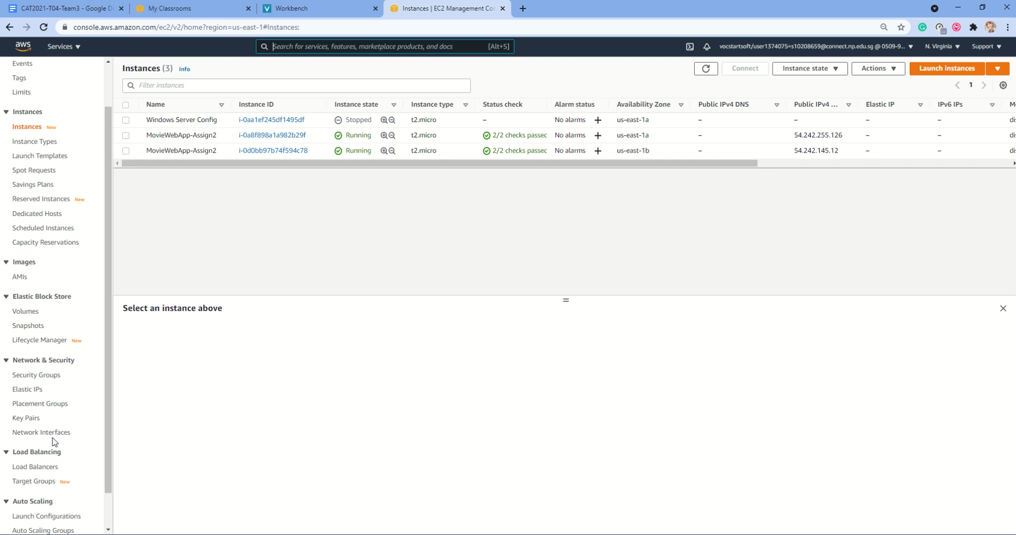

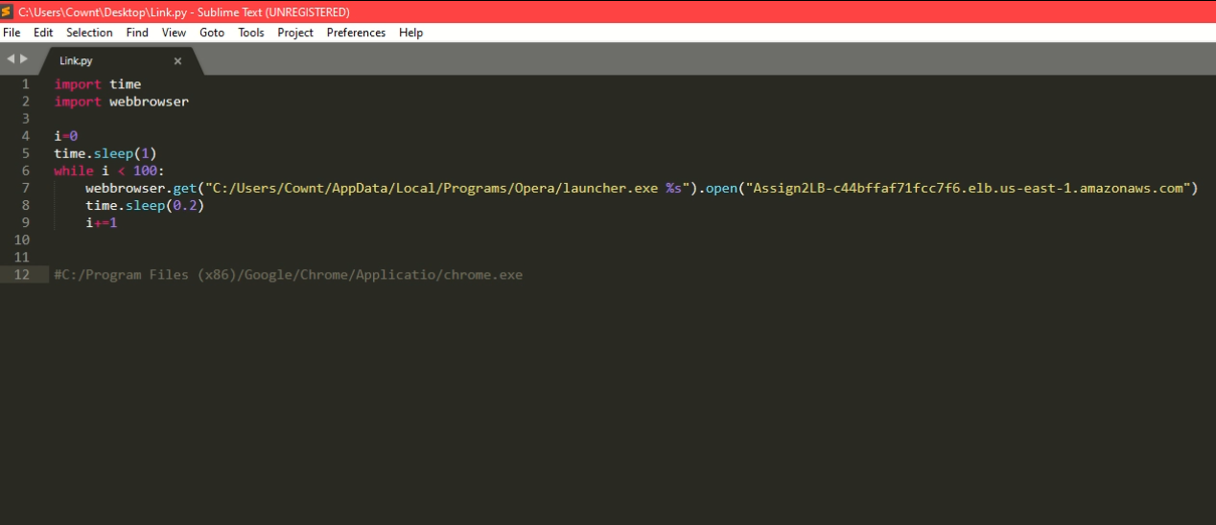

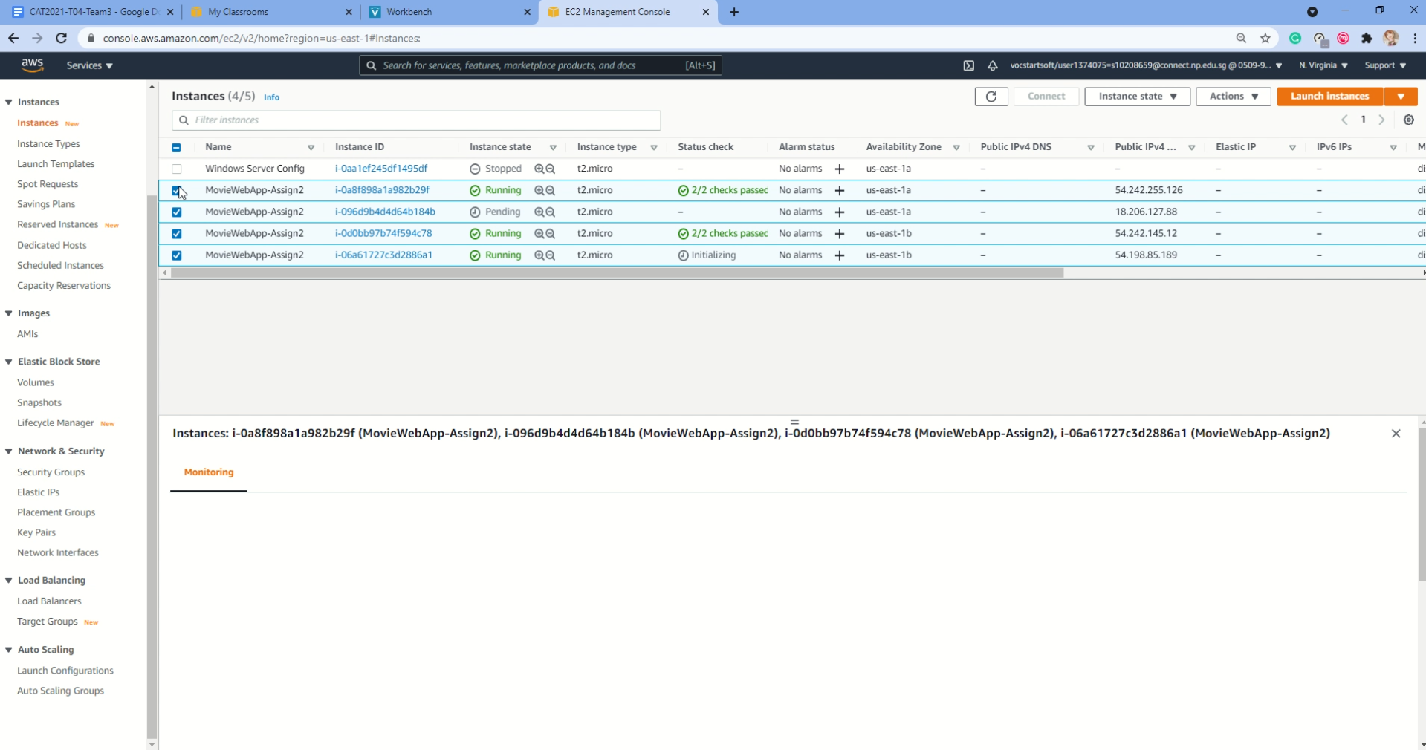

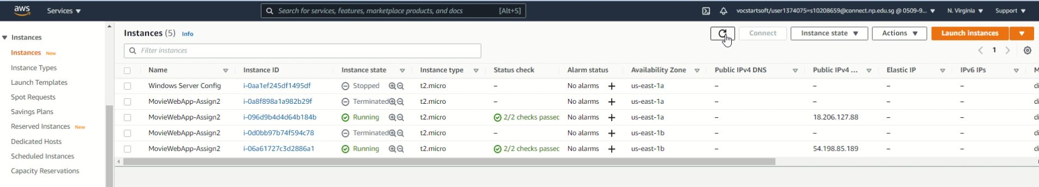

## Testing if all EC2 instances are updated with Amazon RDS data

To test that data is updated to the Amazon RDS, we will go into one instance and create a movie record. After that, we will access another instance and view the data on that web server. When there is a change in data, all webpages are updated as it is retrieving from the Amazon RDS. Hence, showing that any data captured is stored in the Amazon RDS. Additionally, we can go into the Amazon RDS and view the data inside.

